syringe

medicine

plasters

stethoscope

**Medical Word Mat**

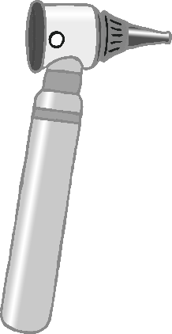

© 2021 Little Owls Resources

bandage

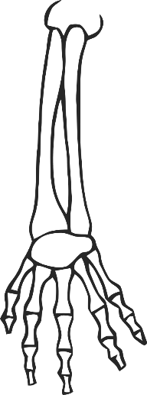

medical gloves

thermometer

fob watch

otoscope

x-ray

clipboard

doctor’s bag