Mark Making Inspiration Cards

These cards are to help inspire children in their mark making as they decide which medium to use. It is hoped that the visual nature of the cards will help children who may have a language or communication barrier.

Different Media

© 2022 Little Owls Resources

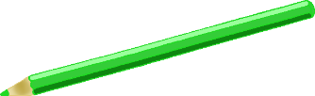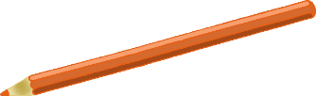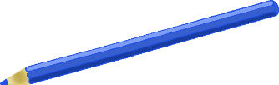

© 2022 Little Owls Resources

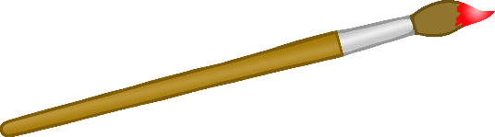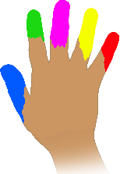

Experiment with…

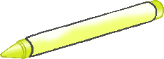

Mark Making

paint

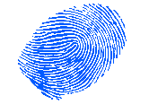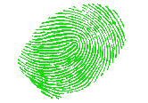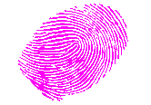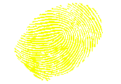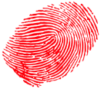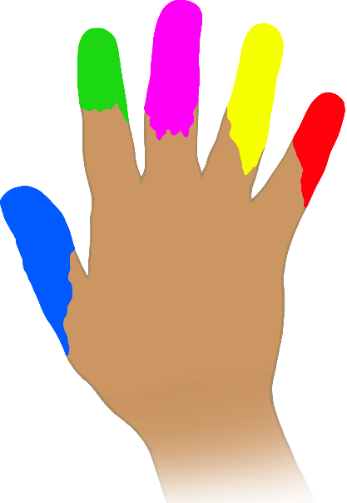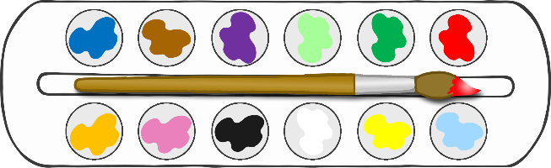

Using your hands!

Using a brush!

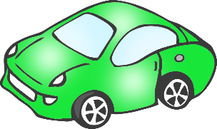

Using an object!

© 2022 Little Owls Resources

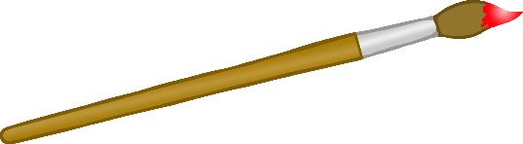

Experiment with…



Mark Making

mud

Using a boot!

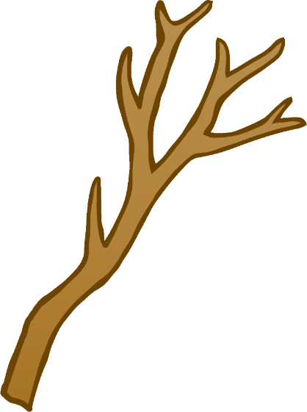

Using a stick!

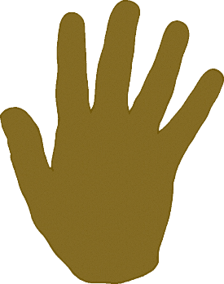

Using your hands!

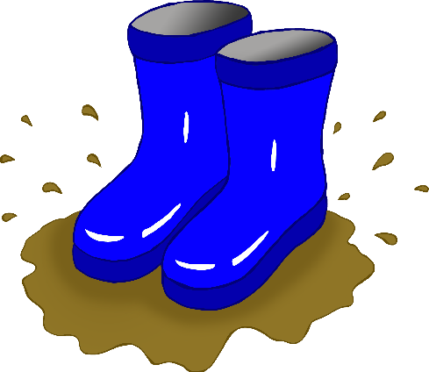

o

y

© 2022 Little Owls Resources



Experiment with…



Mark Making

crayons

On paper!

On sticky notes!

© 2022 Little Owls Resources



Experiment with…



Mark Making

pencils

On sticky notes!

On coloured card!

o

l

l

0

0

o

0

o

o

0

0

o

l

w

w

w

w

On strips of paper!

On a cardboard box!

w

w

y

o

w

l

l

O

© 2022 Little Owls Resources



Experiment with…



Mark Making

water

Using a paintbrush!

© 2022 Little Owls Resources



Experiment with…



Mark Making

shaving foam

Using a brush!

Make tracks with a toy car!

Using your fingers!

On an outside floor!

l

o

On a wall!

© 2022 Little Owls Resources



Experiment with…



Mark Making

pens

On paper shapes!

On coloured card!

© 2022 Little Owls Resources



Experiment with…



Mark Making

chalk

On a wall!

On an outside floor!

On paper!

o

l

l

On sticky notes!

**o**

**s**

**s**

o

o

o

o

o

I

I

(

(

*

(

(

*

(

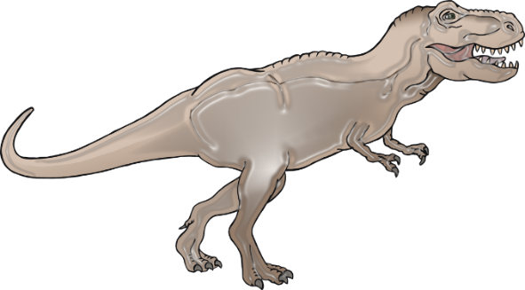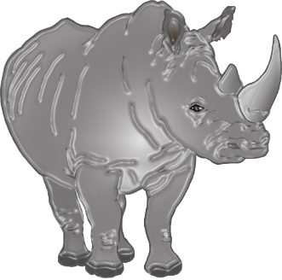

Make impressions using shells!

© 2022 Little Owls Resources



Experiment with…



Mark Making

sand

Make marks with your hands!

© 2022 Little Owls Resources



Experiment with…



Mark Making

playdough

Make footprints using small world toys!

Make impressions using shells!

Make marks with a stick!

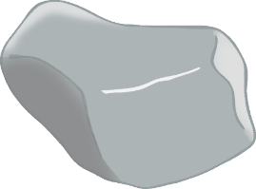

…in mud?

© 2022 Little Owls Resources



Experiment with…



Mark Making

natural materials

Using leaves!

Using sticks and twigs!

© 2022 Little Owls Resources



Experiment with…



Mark Making

kitchen tools

What marks can you make with these tools…

…in playdough?

Using stones!

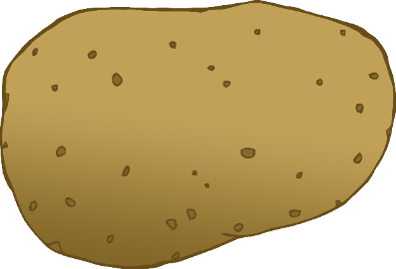

What marks can you make with these foods…

…in mud?

…printing with paint?

© 2022 Little Owls Resources



Experiment with…



Mark Making

food

© 2022 Little Owls Resources



Mark Making