You will need: 2 x metal spoons 2 x plastic cups

2 x duplo bricks 2 x wooden blocks

2 x scrunched papers 2 x cushions

2 x plastic bottles 2 x pencils

* Choose one blue ‘Object’ card and one orange ‘Action’ card.
* Perform the action on the object to create different sounds!

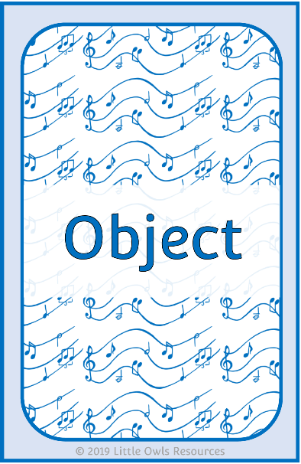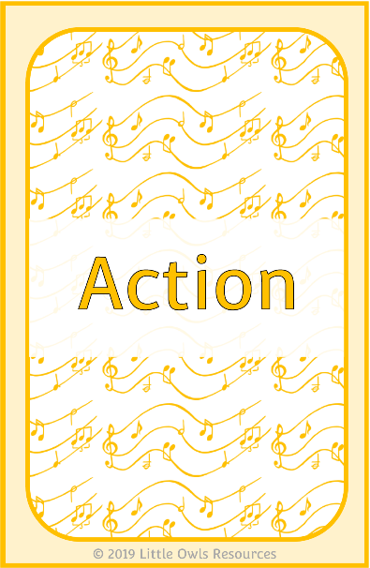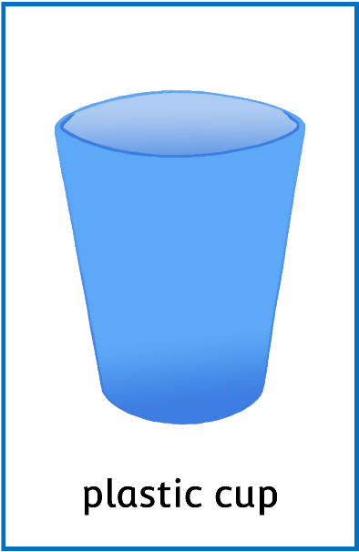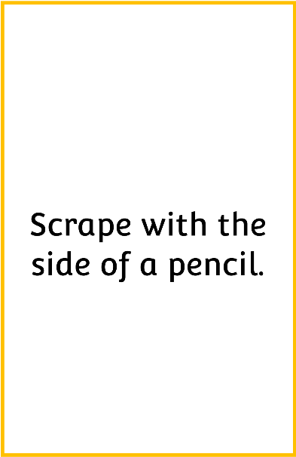

Making Sounds Game

metal spoon

© 2019 Little Owls Resources

© 2019 Little Owls Resources

Tap with the end of a pencil.

Object

Action

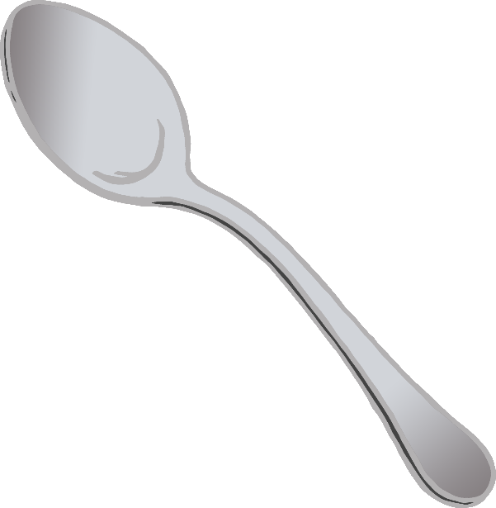

plastic cup

© 2019 Little Owls Resources

© 2019 Little Owls Resources

Tap two of these together.

Object

Action



duplo brick

© 2019 Little Owls Resources

© 2019 Little Owls Resources

Tap on the floor.

Object

Action

wooden block

© 2019 Little Owls Resources

© 2019 Little Owls Resources

Rub on the floor.

Object

Action

scrunched paper

© 2019 Little Owls Resources

© 2019 Little Owls Resources

Scrape with the side of a pencil.

Object

Action

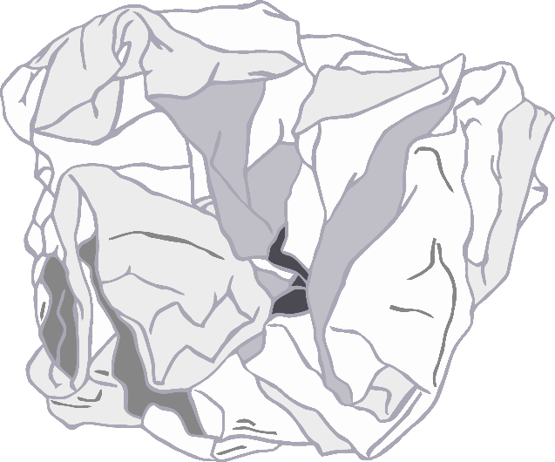

cushion

© 2019 Little Owls Resources

© 2019 Little Owls Resources

Rub two of these together.

Object

Action

plastic bottle

© 2019 Little Owls Resources

© 2019 Little Owls Resources

Scratch with your fingernails.

Object

Action

