**Magpie body parts**

© 2021 Little Owls Resources

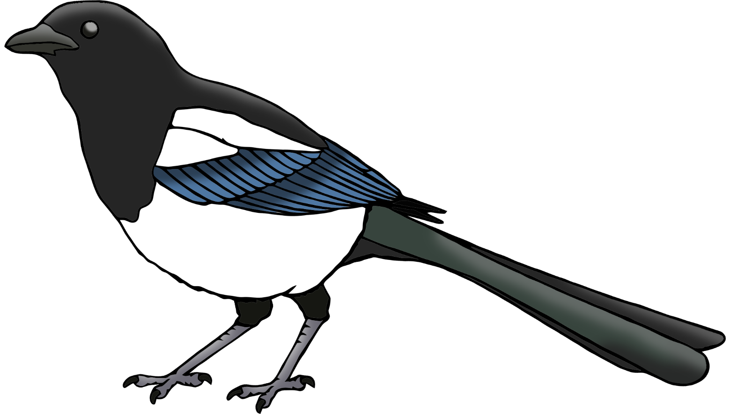

b

h

f

t

**w**

**Magpie body parts**

© 2021 Little Owls Resources



**w**ing

head

tail

foot

beak

**Magpie body parts**

© 2021 Little Owls Resources

