basket

Little Red Riding Hood

wolf

(dressed as Grandma)

Wolf

© 2022 Little Owls Resources

© 2022 Little Owls Resources

© 2022 Little Owls Resources

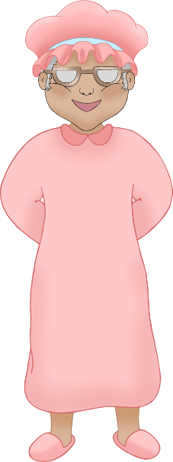

Mum

Grandma

Woodcutter

© 2022 Little Owls Resources

© 2022 Little Owls Resources

© 2022 Little Owls Resources

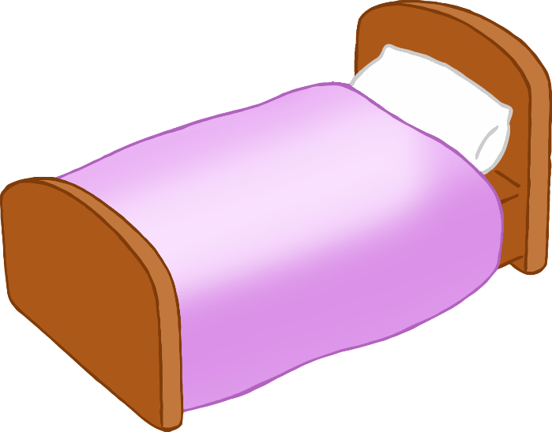

bed

forest

© 2022 Little Owls Resources

© 2022 Little Owls Resources

© 2022 Little Owls Resources

cottage

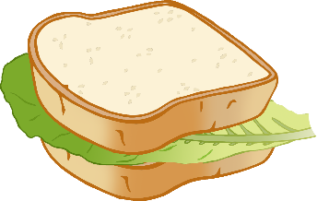

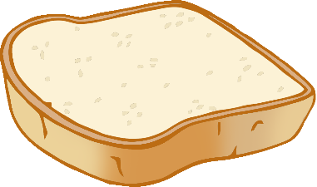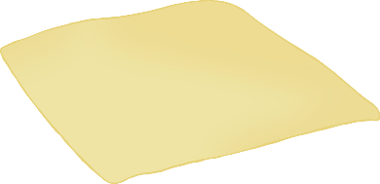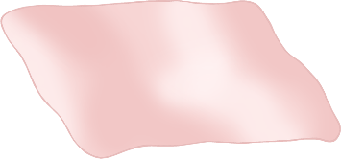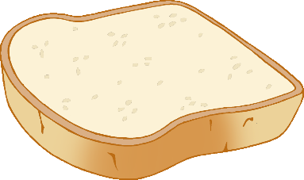

© 2022 Little Owls Resources

food

path

flowers

© 2022 Little Owls Resources

© 2022 Little Owls Resources

© 2022 Little Owls Resources

© 2022 Little Owls Resources

© 2022 Little Owls Resources

wolf eyes

wolf ears

wolf teeth

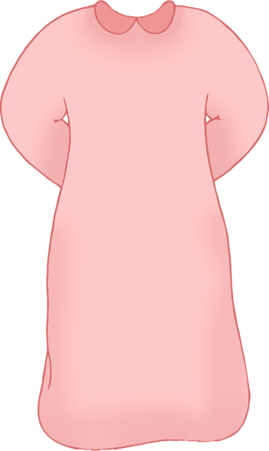

red

bonnet

nightgown

© 2022 Little Owls Resources

© 2022 Little Owls Resources

© 2022 Little Owls Resources