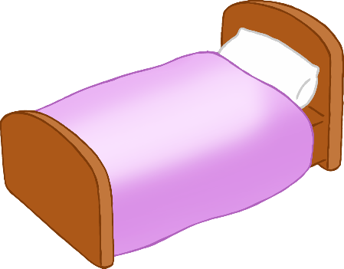

© 2022 Little Owls Resources

**Little Red Riding Hood Word Mat**

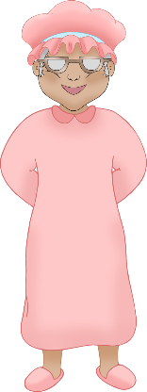

flowers

wolf eyes

wolf ears

wolf teeth

forest

cottage

Woodcutter

Grandma

wolf

bed

Little Red Riding Hood

basket