Little Red Riding Hood

© 2022 Little Owls Resources

© 2022 Little Owls Resources

Little Red Riding Hood

Wolf

© 2022 Little Owls Resources

© 2022 Little Owls Resources

Wolf

Wolf

(dressed as Grandma)

Wolf

(dressed as Grandma)

© 2022 Little Owls Resources

© 2022 Little Owls Resources

Mum

© 2022 Little Owls Resources

© 2022 Little Owls Resources

Mum

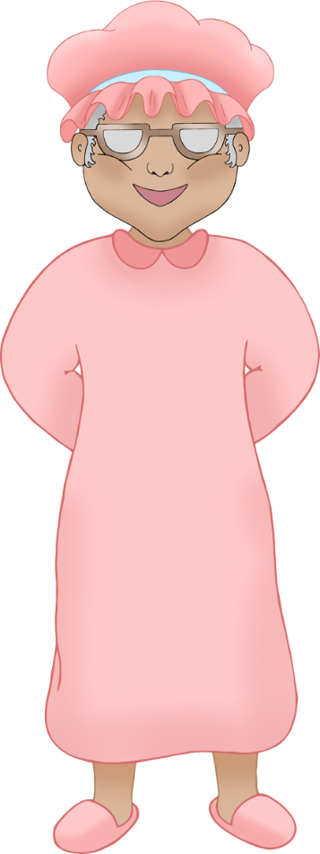



Grandma

© 2022 Little Owls Resources

© 2022 Little Owls Resources

Grandma

Woodcutter

© 2022 Little Owls Resources

© 2022 Little Owls Resources

Woodcutter

Cottage

© 2022 Little Owls Resources

Owls Resources

© 2022 Little Owls Resources

Cottage

Forest

© 2022 Little Owls Resources

© 2022 Little Owls Resources

Forest

Wolf in bed

© 2022 Little Owls Resources

© 2022 Little Owls Resources

Wolf in bed

Basket

Basket

© 2022 Little Owls Resources

© 2022 Little Owls Resources

© 2020 Little Owls Resources

Wolf ears

Wolf ears

© 2022 Little Owls Resources

© 2020 Little Owls Resources

© 2022 Little Owls Resources

Wolf eyes

Wolf eyes

© 2022 Little Owls Resources

© 2022 Little Owls Resources

© 2020 Little Owls Resources

© 2022 Little Owls Resources

© 2020 Little Owls Resources

© 2022 Little Owls Resources

Wolf teeth

Wolf teeth