© 2022 Little Owls Resources

**My Favourite Part**

Little Red Riding Hood

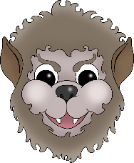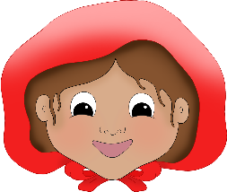

____________________________________________________________________________________

© 2022 Little Owls Resources

**My Favourite Part**

Little Red Riding Hood



________________________________________________________________________________________________________________________________________________________________________________________________

© 2022 Little Owls Resources

**My Favourite Part**

Little Red Riding Hood



© 2022 Little Owls Resources

**My Favorite Part**

Little Red Riding Hood



____________________________________________________________________________________

© 2022 Little Owls Resources

**My Favorite Part**

Little Red Riding Hood



________________________________________________________________________________________________________________________________________________________________________________________________

© 2022 Little Owls Resources

**My Favorite Part**

Little Red Riding Hood

