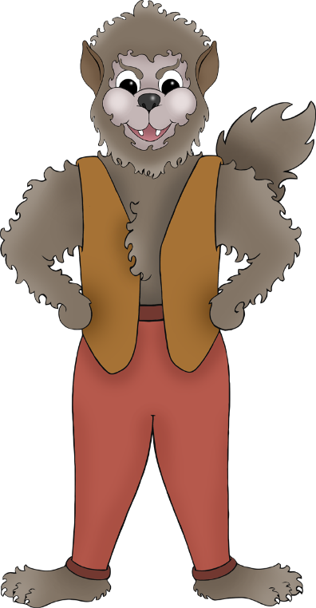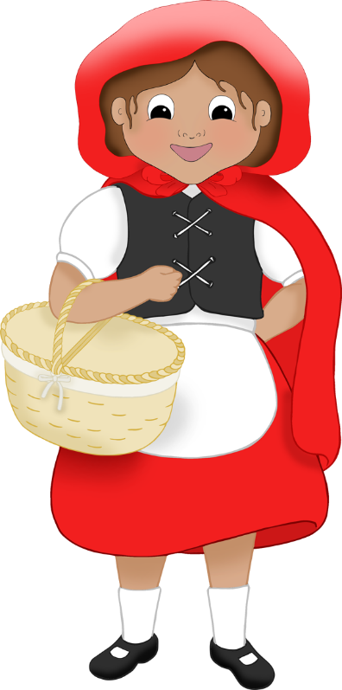

These puppets are to be cut out to stick on lolly sticks.

Three background images are included.

**Little Red Riding Hood**

Lollipop Puppets

© 2022 Little Owls Resources

© 2022 Little Owls Resources

© 2022 Little Owls Resources

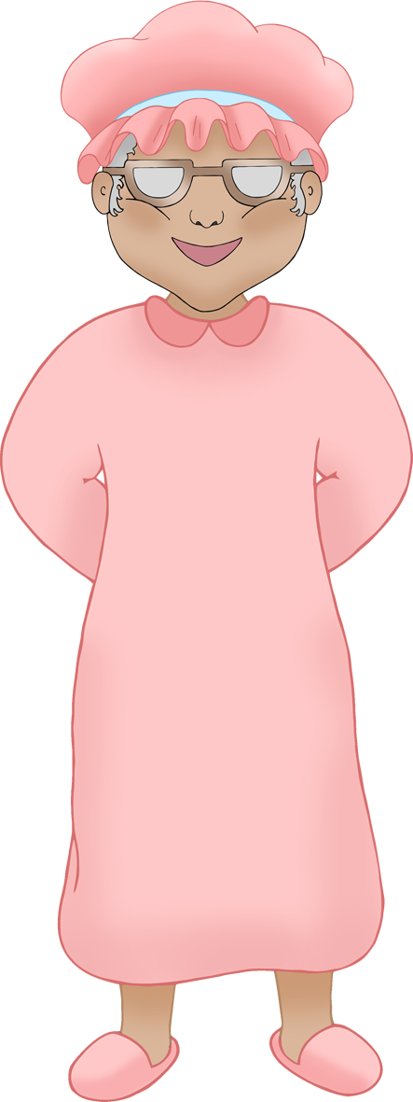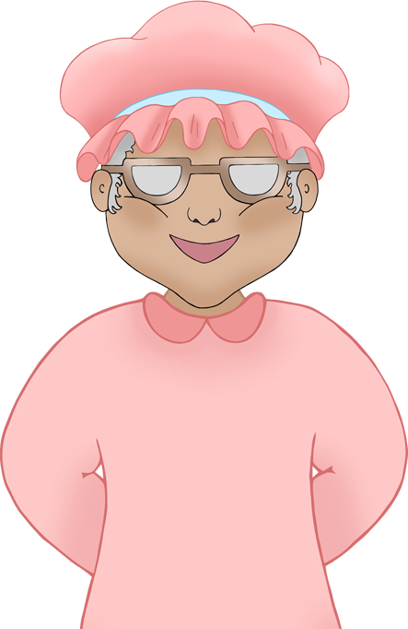

© 2022 Little Owls Resources

© 2022 Little Owls Resources

© 2022 Little Owls Resources

© 2022 Little Owls Resources

© 2022 Little Owls Resources

© 2022 Little Owls Resources

© 2022 Little Owls Resources

© 2022 Little Owls Resources