Character Description Sheets – Little Red Riding Hood

© 2022 Little Owls Resources

These sheets are made for children to think about the characters from the story and record their thoughts.

These thoughts can be written around the pictures by the children if they are able but equally valuable if scribed by an adult.

The discussions and ideas are the most important part of this activity!

At the end of the pack is a short question idea card to get the discussion started but add as many other questions as you like and encourage the children to ask their own questions too!

**Character Description – Little Red Riding Hood**

© 2022 Little Owls Resources

**Character Description – Little Red Riding Hood’s Mother**

© 2022 Little Owls Resources

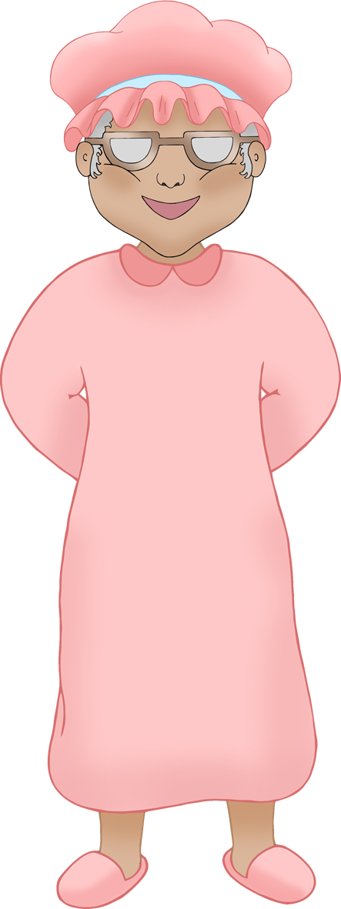

**Character Description – The Big Bad Wolf**

© 2022 Little Owls Resources

**Character Description – Grandmother**

© 2022 Little Owls Resources

**Character Description – Big Bad Wolf (disguised)**

© 2022 Little Owls Resources

**Character Description – Woodcutter**

© 2022 Little Owls Resources

**Character Description Question Ideas**

© 2022 Little Owls Resources

What is (character name) doing in this picture?

How do you think (character name) feels at the end of the story?

What do you think (character name) is saying in the picture?

What happens to (character name) in the story?

How would you describe (character name)? Kind? Nasty? Clever? Silly?

Why?