**Little Red**

© 2022 Little Owls Resources

**Riding Hood**

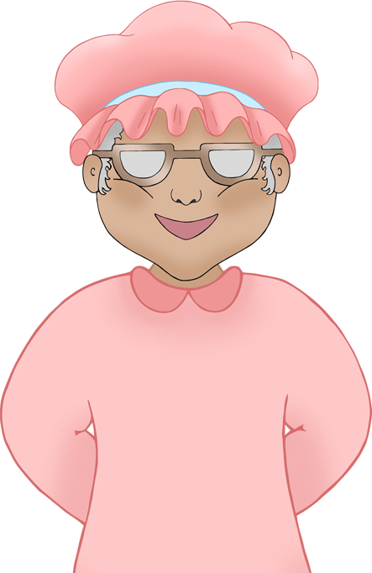

“What big ears you have!”

“All the better to *hear* you with my dear.”

“What big eyes you have!”

“All the better to *see* you with my dear.”

“What big teeth you have!”

“All the better to *EAT* you with my dear!”