**Lion**

The pages of this pack give some general information about lions and some fun and engaging activities to foster and develop children’s interest in them.

**This pack includes:**

* Fact posters x3 (Could be used as stimuli for a lesson input)
* Number slice activity (1-10) (Can be pre-cut for a pure number ordering activity or left to be cut by child to add scissor practice)
* Number slice activity - colouring version (1-10) (As above but to be coloured before cutting)
* Description sheet (Can be used as an independent writing activity or with an adult scribing the ideas of a younger child)
* A4 poster
* A4 poster - colouring version
* ‘Body Parts’ x3 (fully labelled, initial sounds only, blank)
* Draw and write sheets x3 (blank sheet, wide lines and narrow lines)
* 1x 4-piece puzzle
* Multimats x4 (for Colouring/Art & Craft/Loose Parts/Playdough)

© 2021 Little Owls Resources

This pack includes:

The pages of this pack give some general information about the role of a paramedic and some fun and engaging activities to foster and develop children’s interest in this role in society.

Lions usually hunt at night!

**10-15**

© 2021 Little Owls Resources

**Lion Facts**

Wild lions can live for

years.

Lions eat **meat**.

Humans have hunted and killed many lions.

Humans have destroyed lots of places that lions used to live.

This means they are likely to become endangered.

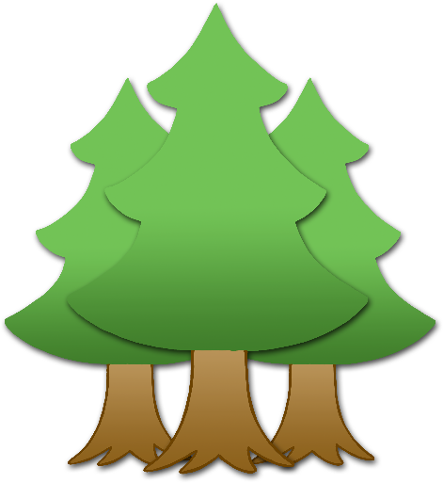

**Lions are** Vunerable.

© 2021 Little Owls Resources

**How big is a Lion?**



180cm / 1.8m

© 2021 Little Owls Resources

1

2

3

4

5

6

7

8

9

10

© 2021 Little Owls Resources

© 2021 Little Owls Resources

1

2

3

4

5

6

7

8

9

10

© 2021 Little Owls Resources

**What words would you use to describe a lion?**

**Lion**

© 2021 Little Owls Resources

**Lion**

© 2021 Little Owls Resources

**Lion body parts**

© 2021 Little Owls Resources

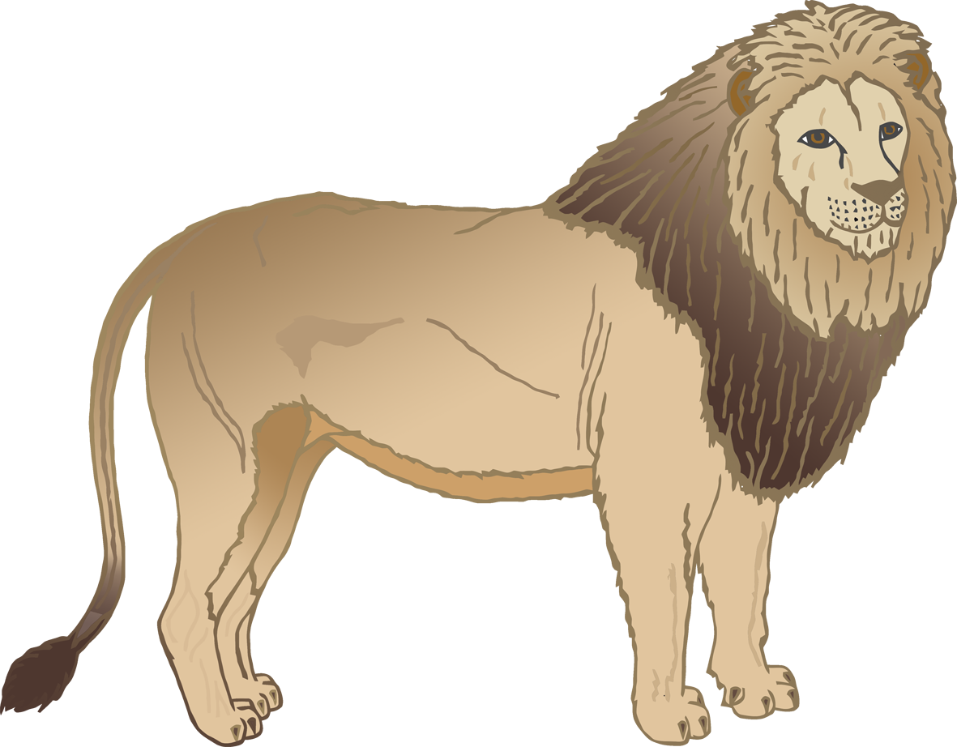

pa**w**

cla**w**

tail

back

ear

eye

**Lion body parts**

© 2021 Little Owls Resources



p

c

t

b

e

e

**Lion body parts**

© 2021 Little Owls Resources

© 2021 Little Owls Resources

**Draw a Lion!**

© 2021 Little Owls Resources

**Draw and write about a Lion!**

____________________________________________________

© 2021 Little Owls Resources

**Draw and write about a Lion!**

______________________________________________________________________________________________________

**Lion**

© 2021 Little Owls Resources

© 2021 Little Owls Resources

**Lion Multimat – Lion**

© 2021 Little Owls Resources

**Lion Multimat – Lion**

© 2021 Little Owls Resources

**Lion Multimat – Footprint**

© 2021 Little Owls Resources

**Lion Multimat – Footprints**