**Lion body parts**

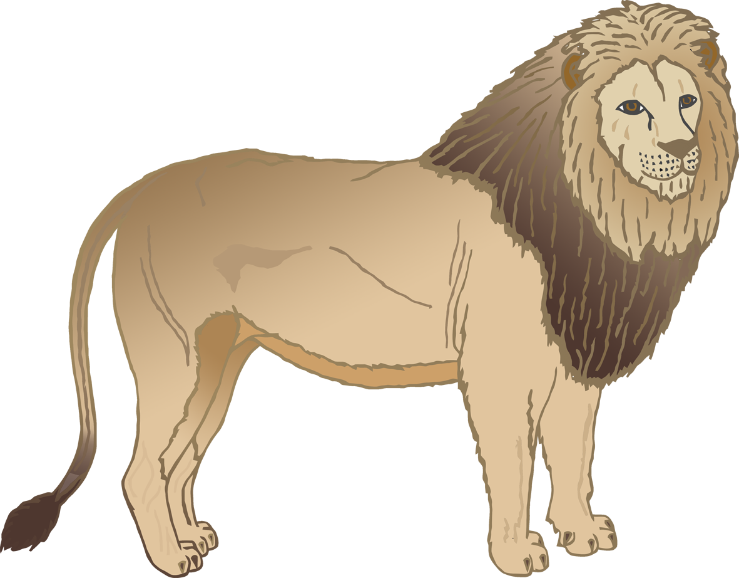

© 2020 Little Owls Resources

t

p

m

m

c

e

**Lion body parts**



© 2020 Little Owls Resources

**Lion body parts**



© 2020 Little Owls Resources

ear

mouth

claw

paw

tail

mane