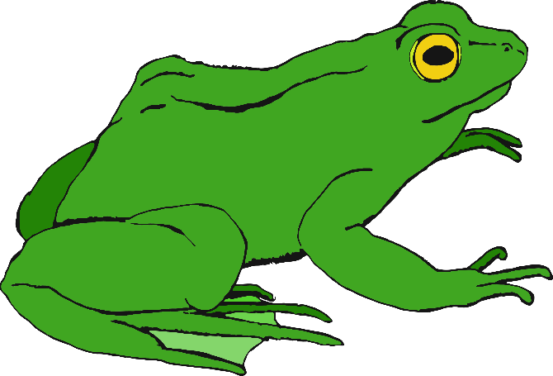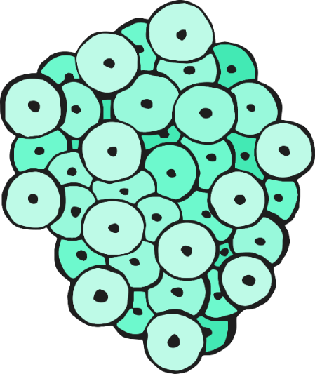

© 2020 Little Owls Resources

© 2020 Little Owls Resources

Owls Resources

frogspawn

frog

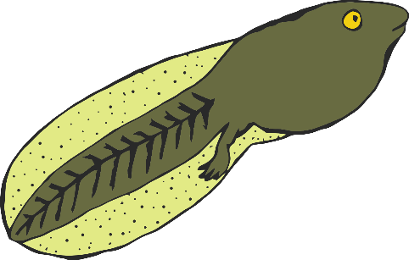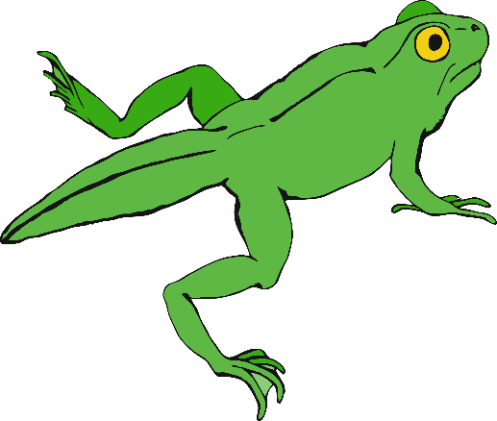

tadpole

froglet

© 2020 Little Owls Resources

© 2020 Little Owls Resources

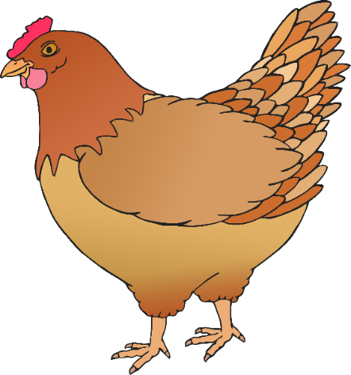

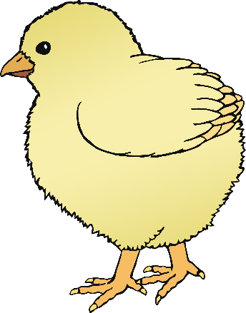

chick

egg

chicken

© 2020 Little Owls Resources

© 2020 Little Owls Resources

© 2020 Little Owls Resources

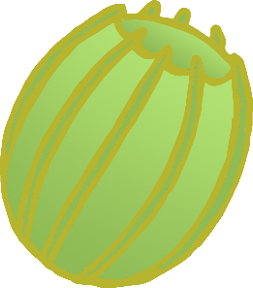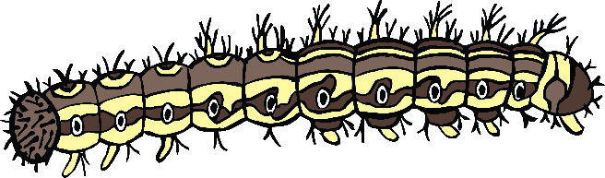

caterpillar

egg

© 2020 Little Owls Resources

© 2020 Little Owls Resources

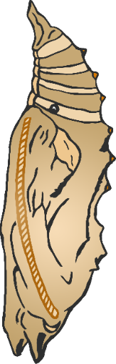

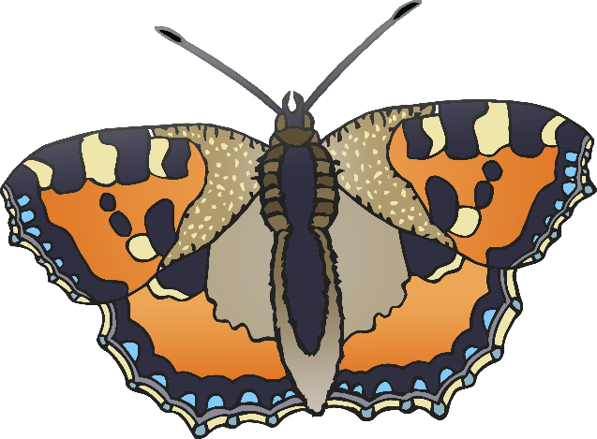

© 2020 Little Owls Resources

© 2020 Little Owls Resources

butterfly

chrysalis

© 2020 Little Owls Resources

© 2020 Little Owls Resources

egg

larva

© 2020 Little Owls Resources

© 2020 Little Owls Resources

ant

pupa

© 2020 Little Owls Resources

© 2020 Little Owls Resources

seed

sprout

seedling

flowers/fruit

© 2020 Little Owls Resources

© 2020 Little Owls Resources