**Life Cycle Actions – Frog 1**

Pretend you are some wobbly **frogspawn** floating on a pond.

* Lie down on the floor. Make some very small movements as if the water is moving below you.
* The wind blows! Wobble quickly for a moment before slowing down again.

**Life Cycle Actions – Frog 2**

Pretend you are a **tadpole** breaking free from the frogspawn.

* Make yourself small in a ball.
* Wriggle, wriggle, wriggle and break free!
* Swim here, swim there. Little quick movements. Watch out for big fish! Hide!

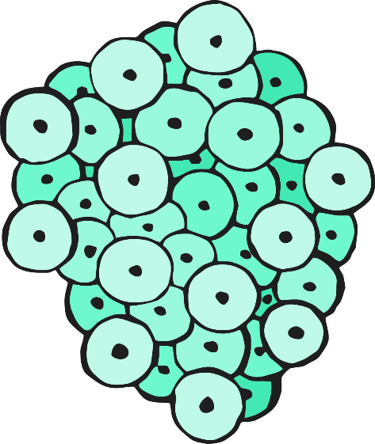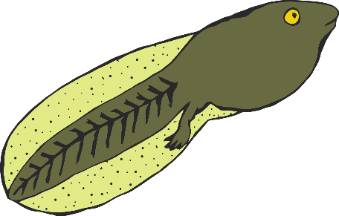

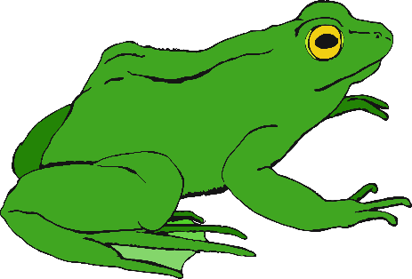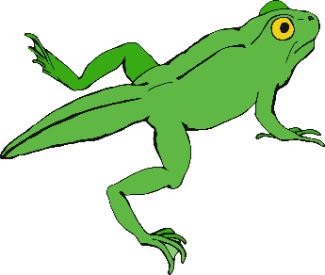

**Life Cycle Actions – Frog 3**

Pretend you are a growing **froglet** exploring the pond.

* You can swim faster now using your new back legs.
* Move around the pond. If you see any little insects in the water gobble them up!

**Life Cycle Actions – Frog 4**

Pretend you are a **frog** leaving the pond on your strong jumping legs.

* Hop out of the pond.
* Use your strong back legs to jump, jump, jump!
* Catch that worm for dinner!
* A cat is coming! Back to the pond! Splash!

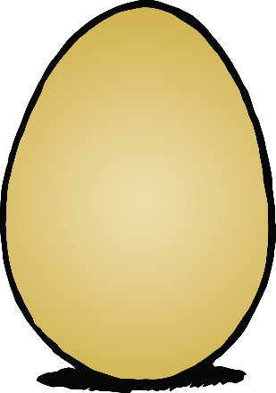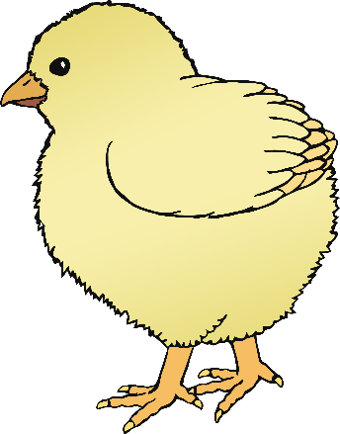

**Life Cycle Actions – Chicken 2**

Pretend you are a **chick** just out of your shell.

* Hold your hands at your sides and move in little steps around.
* Look at the floor for food… bob your head… scratch with your feet.

**Life Cycle Actions – Chicken 1**

Pretend you are a chicken’s **egg**.

* Make your body very small; curled up on the floor.
* Very slowly, start to crack the shell and stretch up and out. How slowly can you do it?

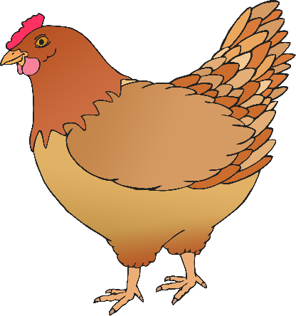

**Life Cycle Actions – Chicken 3**

Pretend you are a **chicken**.

* Walk around with your back straight.
* Peck for food if you see any on the floor.
* A fox! Quick, flap your wings to jump away! Get back to the coop!

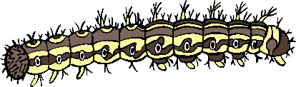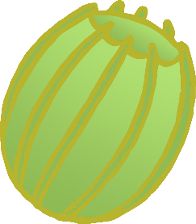

**Life Cycle Actions – Butterfly 2**

**Life Cycle Actions – Butterfly 1**

Pretend you are a **caterpillar** breaking free from the egg.

* Push your caterpillar head forward and squeeze out of the egg.
* First, turn around and eat the egg.
* Now crawl, crawl, crawl to find lots of food!

Pretend you are a butterfly **egg** stuck to a leaf.

* Curl up in a ball. Try to keep as still as possible.
* The wind blows but you are so tiny and stuck so strongly that you only wobble a little.

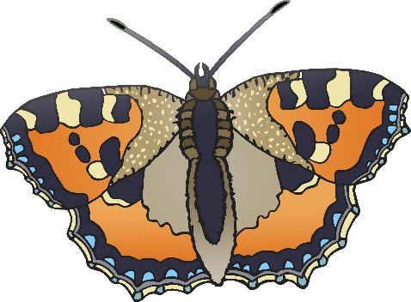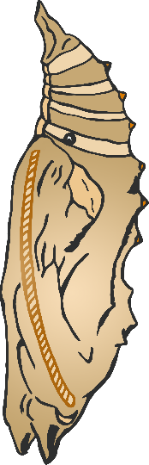

**Life Cycle Actions – Butterfly 4**

**Life Cycle Actions – Butterfly 3**

Pretend you are a **chrysalis** stuck to a branch.

* Make you body very strong. You are stuck to the branch.
* Keep your body strong but do some tiny wiggles as your caterpillar body begins to change inside the chrysalis.

Pretend you are a beautiful **butterfly**.

* Break out of the chrysalis. Wait for a moment to let you wings expand. Stretch out your arms!
* Now flap those wings so silently to visit lots of flowers.