**Let’s show…**

kindness

These prompt cards are ideas for showing kindness.

These ideas will hopefully spark more of your own and those of the children too!

We hope this helps!

© 2023 Little Owls Resources

© 2023 Little Owls Resources

Hug someone you care about.

**Let’s show…**



kindness

© 2023 Little Owls Resources

Be a friend to someone who is sad.

**Let’s show…**



kindness

© 2023 Little Owls Resources

Have a nice chat with someone.

**Let’s show…**



kindness

© 2023 Little Owls Resources

Share your favourite book with a friend.

**Let’s show…**



kindness

Thank-you.

I love your haircut!

© 2023 Little Owls Resources

Say thank-you.

**Let’s show…**



kindness

© 2023 Little Owls Resources

Pay someone a compliment.

**Let’s show…**



kindness

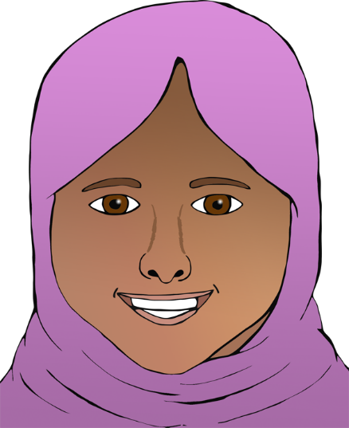

© 2023 Little Owls Resources

Open a door for someone.

**Let’s show…**



kindness

© 2023 Little Owls Resources

Smile.

**Let’s show…**



kindness

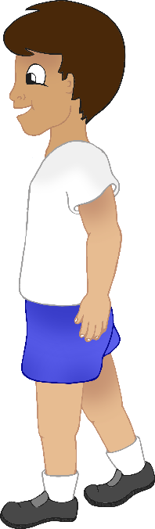

Thank-you!

© 2023 Little Owls Resources

Send a thank-you note.

**Let’s show…**



kindness

© 2023 Little Owls Resources

Let someone ahead of you in a line.

**Let’s show…**



kindness

Are you okay?

Well done me!

© 2023 Little Owls Resources

Say well done to yourself!

**Let’s show…**



kindness

© 2023 Little Owls Resources

Ask someone how they are doing.

**Let’s show…**



kindness

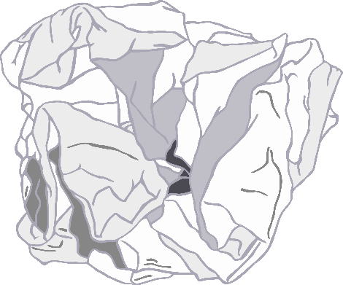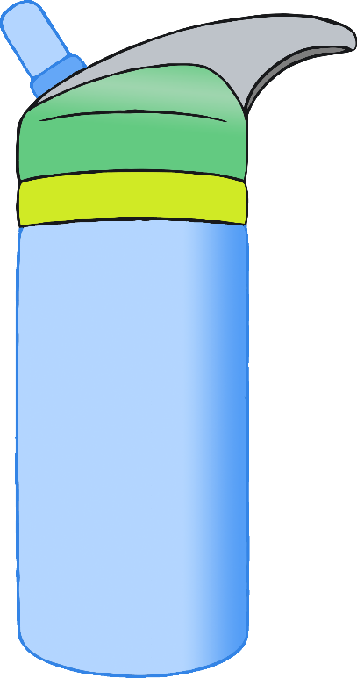

© 2023 Little Owls Resources

Drink some water and encourage a friend to as well.

**Let’s show…**



kindness

© 2023 Little Owls Resources

Pick up rubbish.

**Let’s show…**



kindness

Please.

© 2023 Little Owls Resources

Take a walk with a friend.

**Let’s show…**



kindness

© 2023 Little Owls Resources

Say please.

**Let’s show…**



kindness

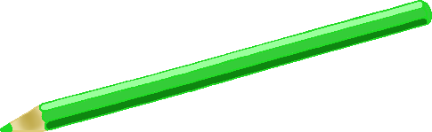

© 2023 Little Owls Resources

Draw a picture for a friend.

**Let’s show…**



kindness

© 2023 Little Owls Resources

Tell someone you love that you love them!

**Let’s show…**



kindness

© 2023 Little Owls Resources

Be helpful to the adults that help you!

**Let’s show…**



kindness

© 2023 Little Owls Resources

Write a letter or draw a picture for your grandparents.

**Let’s show…**



kindness

© 2023 Little Owls Resources

**Let’s show…**



kindness

© 2023 Little Owls Resources

**Let’s show…**



kindness