Let’s get…

moving

These prompt cards are ideas for movement activities.

As well as being good for the body, movement and exercise are also an important part of a healthy mind!

We hope this helps!

© 2023 Little Owls Resources

© 2023 Little Owls Resources

Play a game at the park!

Let’s get…

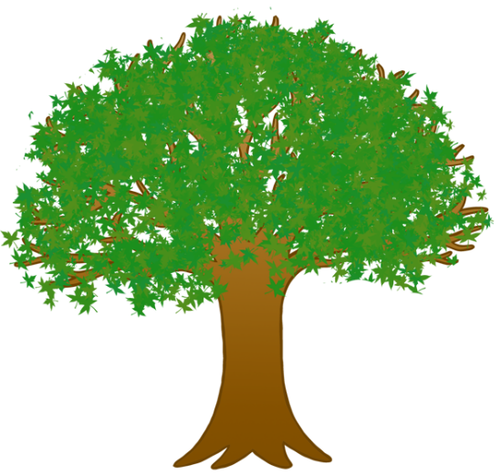

moving

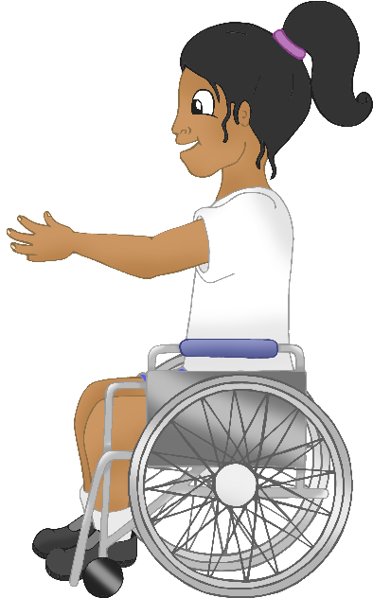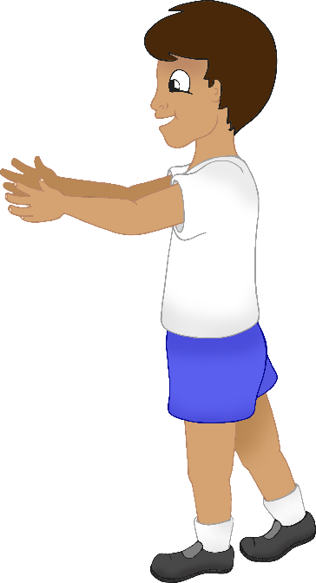

© 2023 Little Owls Resources

Dance to some music!

Let’s get…



moving

© 2023 Little Owls Resources

Try some yoga!

Let’s get…



moving

© 2023 Little Owls Resources

Go for a walk!

Let’s get…



moving

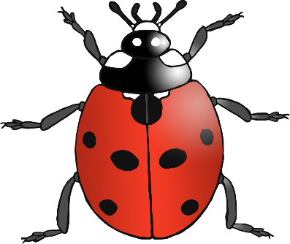

© 2023 Little Owls Resources

Go for a nature walk to find minibeasts!

Let’s get…



moving

© 2023 Little Owls Resources

Do some gardening!

Let’s get…



moving

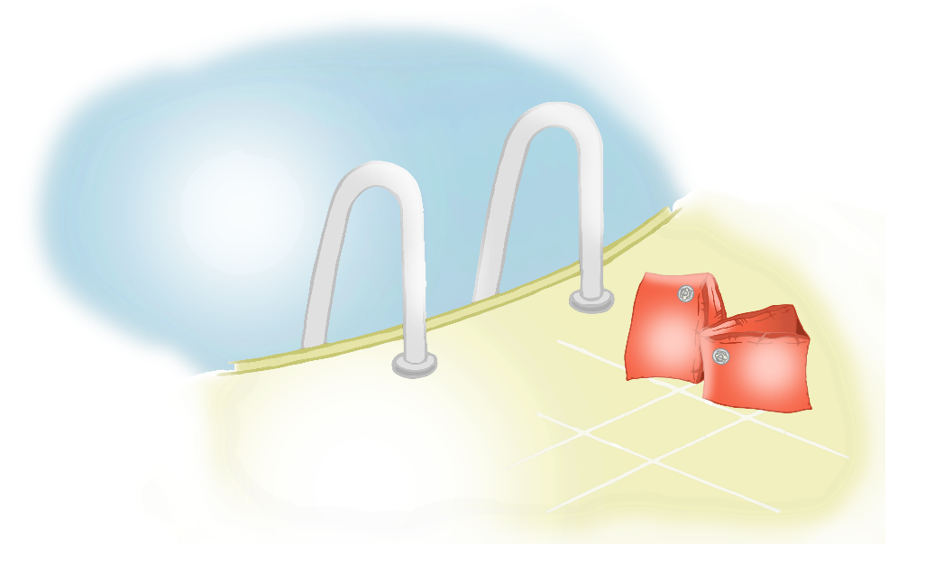

© 2023 Little Owls Resources

Make an obstacle course!

Let’s get…



moving

© 2023 Little Owls Resources

Go for a swim!

Let’s get…



moving

© 2023 Little Owls Resources

Enjoy a treasure hunt!

Let’s get…



moving

© 2023 Little Owls Resources

Play hide and seek!

Let’s get…



moving

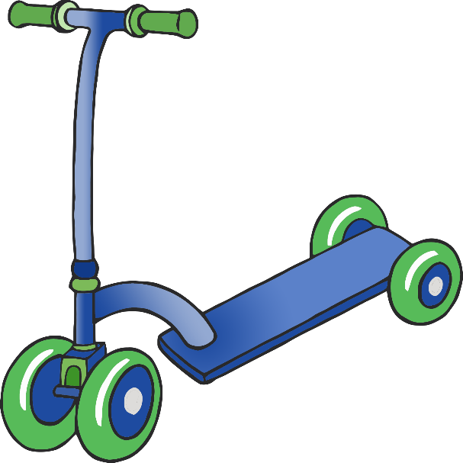

© 2023 Little Owls Resources

Play on ride-ons!

*Tricycles, bikes, scooters*

Let’s get…



moving

© 2023 Little Owls Resources

Role-play!

*Move like a…*

Let’s get…



moving

See the little bunny rabbits…

Find a circle!

Run to the triangle!

© 2023 Little Owls Resources

Go on a maths hunt!

Let’s get…



moving

© 2023 Little Owls Resources

Act out nursery rhymes!

Let’s get…



moving

© 2023 Little Owls Resources

Play on playground equipment!

Let’s get…



moving

© 2023 Little Owls Resources

Help with household chores!

Let’s get…



moving

© 2023 Little Owls Resources

Run a race!

Let’s get…



moving

© 2023 Little Owls Resources

Bounce a ball!

Let’s get…



moving

© 2023 Little Owls Resources

Build a den!

Let’s get…



moving

© 2023 Little Owls Resources

Practise hula hooping!

Let’s get…



moving

© 2023 Little Owls Resources

Let’s get…



moving

© 2023 Little Owls Resources

Let’s get…



moving