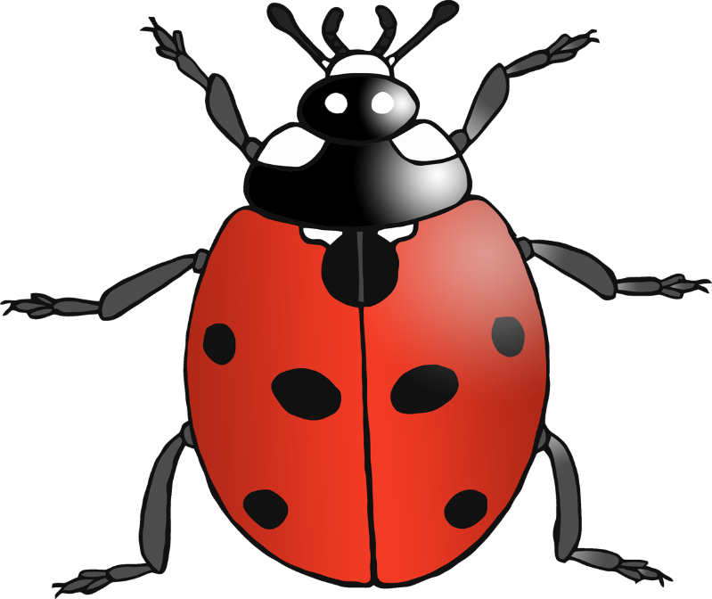

that

© 2020 Little Owls Resources



**w**ill

© 2020 Little Owls Resources



this

© 2020 Little Owls Resources



then

© 2020 Little Owls Resources



down

© 2020 Little Owls Resources



now

© 2020 Little Owls Resources



look

© 2020 Little Owls Resources



too

© 2020 Little Owls Resources



**w**ith

© 2020 Little Owls Resources



them

© 2020 Little Owls Resources



see

© 2020 Little Owls Resources



for

© 2020 Little Owls Resources



she

© 2020 Little Owls Resources



he

© 2020 Little Owls Resources



**w**e

© 2020 Little Owls Resources



me

© 2020 Little Owls Resources



**w**as

© 2020 Little Owls Resources



be

© 2020 Little Owls Resources



they

© 2020 Little Owls Resources



you

© 2020 Little Owls Resources



are

© 2020 Little Owls Resources



all

© 2020 Little Owls Resources



her

© 2020 Little Owls Resources



my

© 2020 Little Owls Resources