**Kids Olympics**

My Teddy

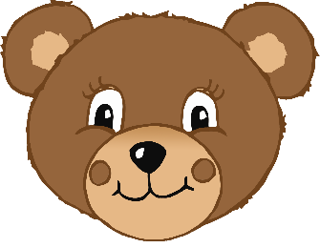

© 2021 Little Owls Resources

________________________________________________________________________________________________________

**Kids Olympics**

____________________________

© 2021 Little Owls Resources

© 2020 Little Owls Resources

**Kids Olympics**

© 2021 Little Owls Resources

Our Sports Day

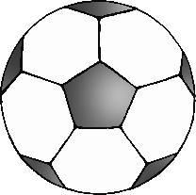

My Teddy



© 2021 Little Owls Resources

________________________________________________________________________________________________________

Our Sports Day



____________________________

© 2021 Little Owls Resources

© 2020 Little Owls Resources

Our Sports Day

