**Kids Olympics**

This pack is designed to be used to organise a sports event for young children that can be scaled according to the size of setting.

*N.B. Before starting, it would be useful to laminate the cards to protect them.*

There are eight stations of sporty activities for the children to experience. Although these activities are not strenuous, a water-drinking station is included to get them thinking about the importance of hydration during exercise.

Each station is designed to last for ten seconds, but this can be altered if needed.

After setting up the stations with the cards and equipment assign a child or children to each station.

1. Get the children to look at the station card and ensure they understand what they must do.
2. When the children are ready, start counting as a group from 1-10. During this time, the children must continually perform the task on their cards.
3. After 10 seconds, everybody claps and then moves around to the next station (see overview sheet – p2 in this pack)
4. Repeat steps 1-3 until all stations are complete.

Enjoy!

© 2021 Little Owls Resources

© 2021 Little Owls Resources

**Kids Olympics**

8

Throw

7

Bounce

Jump

6

Water

5

4

Stretch

Jog

3

Hop

2

1

Balance

© 2021 Little Owls Resources

**Kids Olympics**

1

Balance

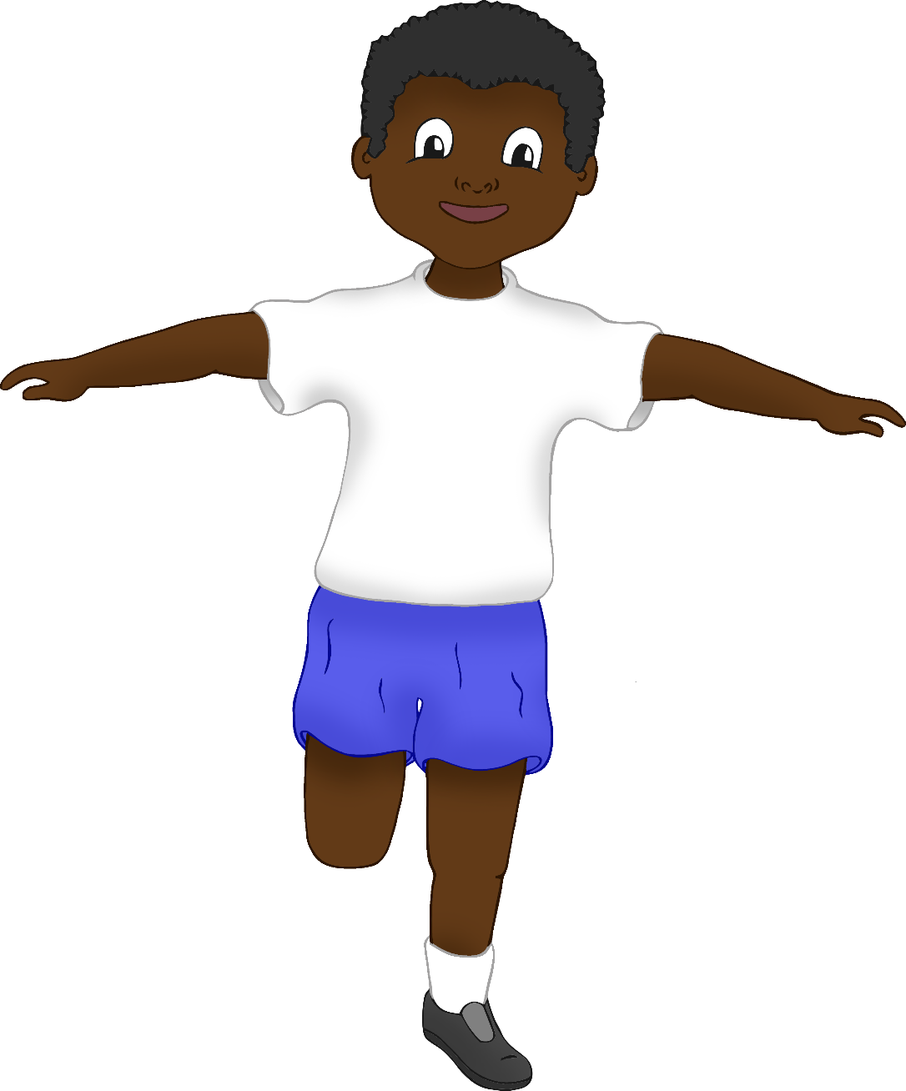

© 2021 Little Owls Resources

**Kids Olympics**

2

Hop

© 2021 Little Owls Resources

**Kids Olympics**

3

Jog

© 2021 Little Owls Resources

**Kids Olympics**

4

Stretch

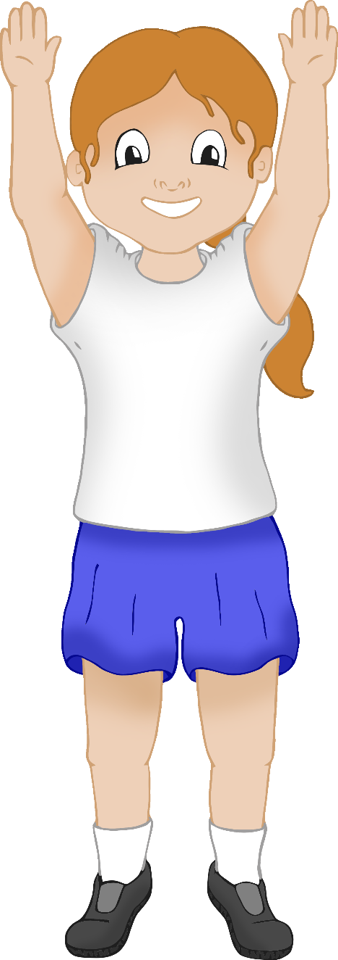

© 2021 Little Owls Resources

**Kids Olympics**

5

Water

© 2021 Little Owls Resources

**Kids Olympics**

6

Jump

© 2021 Little Owls Resources

**Kids Olympics**

7

Bounce

© 2021 Little Owls Resources

**Kids Olympics**

8

Throw