English/Ukrainian

© 2022 Little Owls Resources

no

ні

(nee)

English/Ukrainian

© 2022 Little Owls Resources

**✔️**

yes

так

(tuk)

hello

Вітаю or Привіт

(vit-eye-oh) or (priv-eet)

English/Ukrainian

© 2022 Little Owls Resources

goodbye

до побачення or бувай

(doh-poh-but-chin-ya)

or (boov-eye)

English/Ukrainian

© 2022 Little Owls Resources

please

будь ласка

(bood-luss-kah)

English/Ukrainian

© 2022 Little Owls Resources

thank-you

Дякую

(dyaka-yoh)

English/Ukrainian

© 2022 Little Owls Resources

mummy

мама

(muh-muh)

English/Ukrainian

© 2022 Little Owls Resources

daddy

тато

(tah-toh)

English/Ukrainian

© 2022 Little Owls Resources

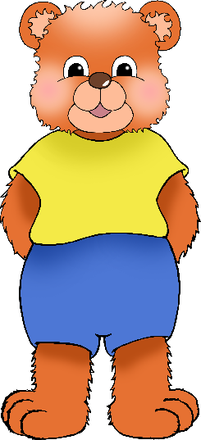

cuddle

обіймаються

(oh-beem-eye-oot-sah)

English/Ukrainian

© 2022 Little Owls Resources

Play (fun)

бавитися

(bar-vuh-tih-sah)

English/Ukrainian

/Portuguese

English/Portuguese

English/Portuguese

English/Portuguese

English/Portuguese

English/Portuguese

English/Portuguese

English/Portuguese

© 2022 Little Owls Resources

thirsty

спраглий

(spr-ar-lee)

English/Ukrainian

© 2022 Little Owls Resources

hungry

голодний

(hol-od-nee)

English/Ukrainian

© 2022 Little Owls Resources

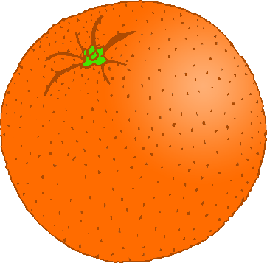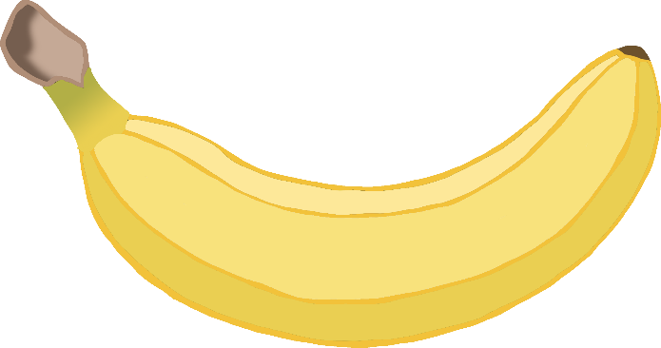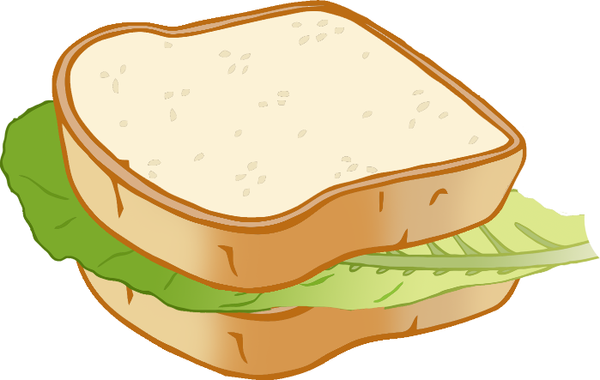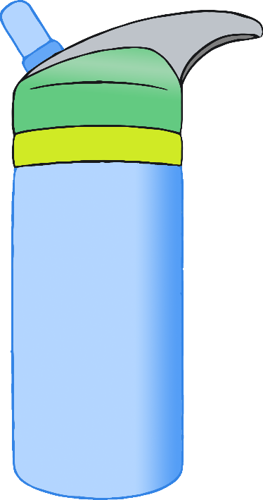

hurt / pain

боляче / біль

(boh-leh-cha / bil)

English/Ukrainian

© 2022 Little Owls Resources

unwell / sick

нездужання / недужий

(nez-doozj-enya / ned-uh-zjee)

English/Ukrainian

© 2022 Little Owls Resources

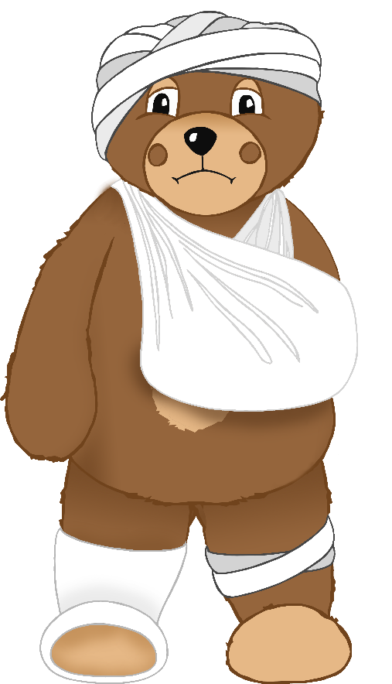

tired

втомився

(vt-om-oov-ssya)

English/Ukrainian

© 2022 Little Owls Resources

toilet

туалет

(too-ar-lett)

English/Ukrainian

© 2022 Little Owls Resources

