English/Spanish

© 2021 Little Owls Resources

no

no

(no)

English/Spanish

© 2021 Little Owls Resources

**✔️**

yes

sí

(see)

hello

hola

(oh-lah)

English/Spanish

© 2022 Little Owls Resources

goodbye

adios

(ad-ee-oss)

English/Spanish

© 2022 Little Owls Resources

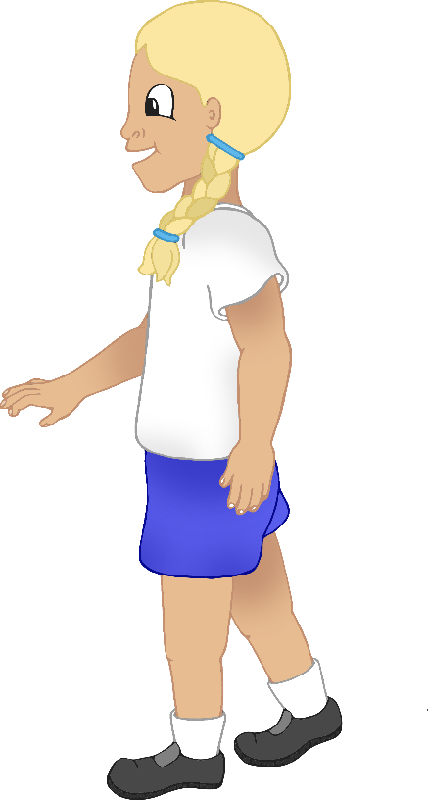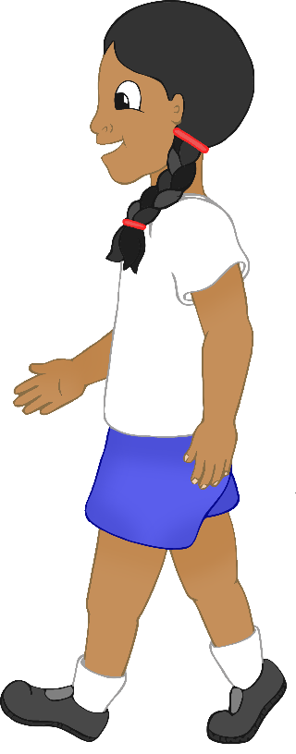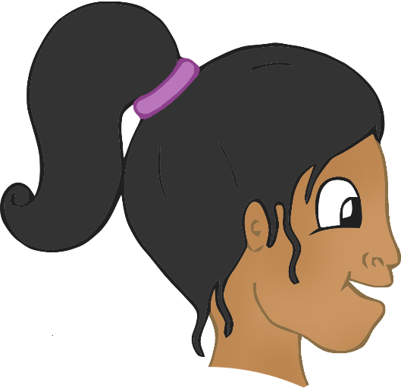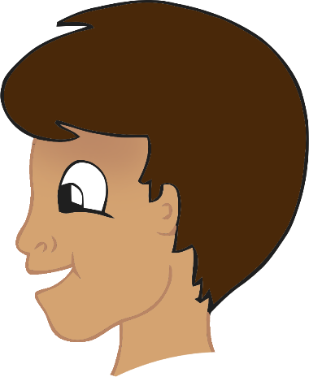

thank-you

gracias

(grath-ee-ass) or (gra-see-ass)

English/Spanish

© 2022 Little Owls Resources

please

por favor

(por-fav-or)

English/Spanish

© 2022 Little Owls Resources

mummy

mamá

(ma-ma)

English/Spanish

© 2021 Little Owls Resources

daddy

papá

(pah-pah)

English/Spanish

© 2021 Little Owls Resources

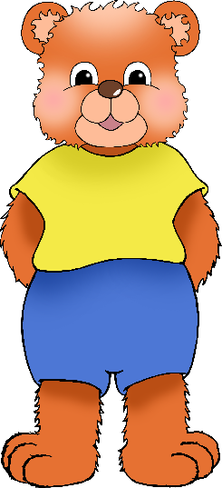

cuddle

abrazo

(a-brath-oh)

English/Spanish

© 2021 Little Owls Resources

play

jugar

(khoo-gar)

English/Spanish

© 2021 Little Owls Resources

thirsty

sediento

(sed-ee-en-toe)

English/Spanish

© 2021 Little Owls Resources

hungry

hambriento

(am-bree-en-toe)

English/Spanish

© 2021 Little Owls Resources

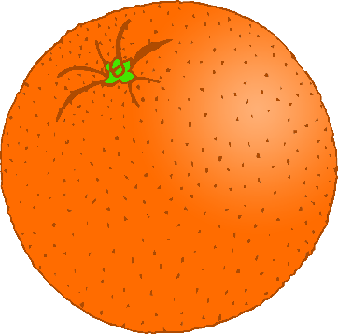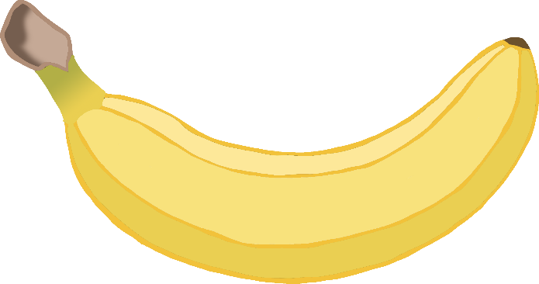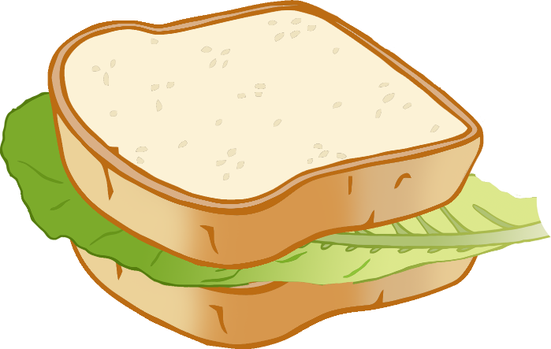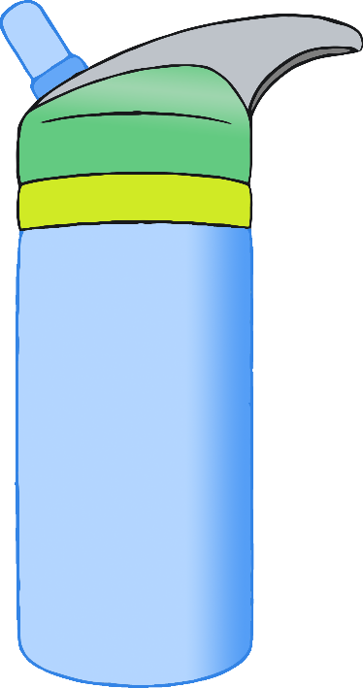

hurt

herido

(eh-ree-doh)

English/Spanish

© 2021 Little Owls Resources

unwell

mal

(mal)

English/Spanish

© 2021 Little Owls Resources

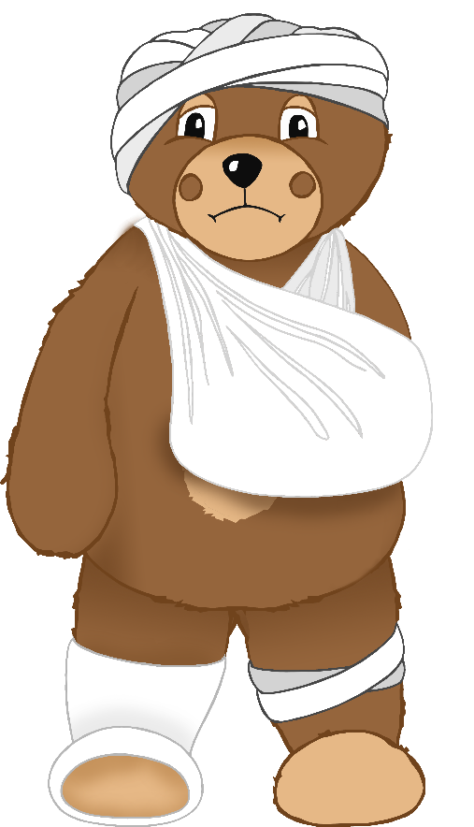

tired

cansado

(can-sah-doh)

English/Spanish

© 2021 Little Owls Resources

toilet

baño

(ban-yo)

English/Spanish

© 2021 Little Owls Resources

