English/German

© 2021 Little Owls Resources

no

nein

(n-eye-n)

English/German

© 2021 Little Owls Resources

**✔️**

yes

ja

(yar)

goodbye

auf Wiedersehen or tschüss

(ow-feeder-zayn) or (chooss)

English/German

© 2022 Little Owls Resources

hello

hallo or Guten Tag

(Hah-loh) or (goot-en-targ)

English/German

© 2022 Little Owls Resources

please

bitte

(bitt-uh)

English/German

© 2022 Little Owls Resources

thank-you

danke

(dan-kuh)

English/German

© 2022 Little Owls Resources

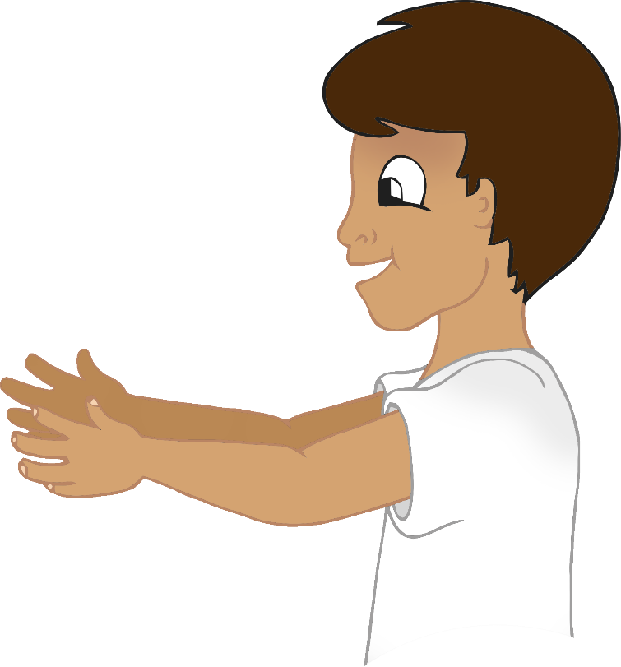

mummy

Mama

(muh-muh)

English/German

© 2021 Little Owls Resources

daddy

Papa

(puh-puh)

English/German

© 2021 Little Owls Resources

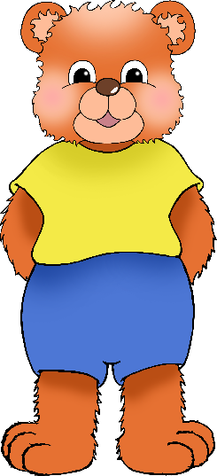

cuddle

Kuscheln

(cuhr-shen)

English/German

© 2021 Little Owls Resources

play

spielen

(sh-pee-un)

English/German

/Portuguese

English/Portuguese

English/Portuguese

English/Portuguese

English/Portuguese

English/Portuguese

English/Portuguese

English/Portuguese

© 2021 Little Owls Resources

thirsty

durstig

(duhr-stikh)

English/German

© 2021 Little Owls Resources

hungry

hungrig

(hoon-grikh)

English/German

© 2021 Little Owls Resources

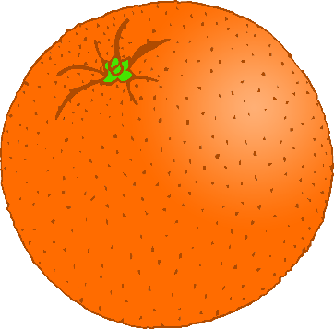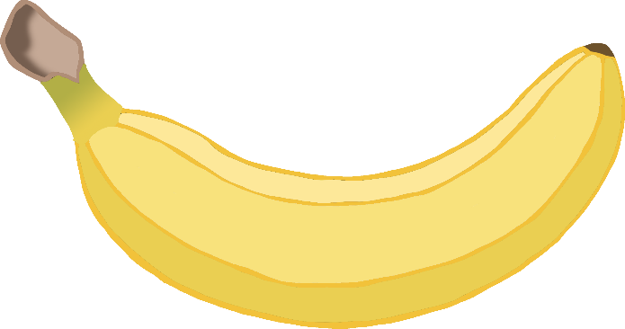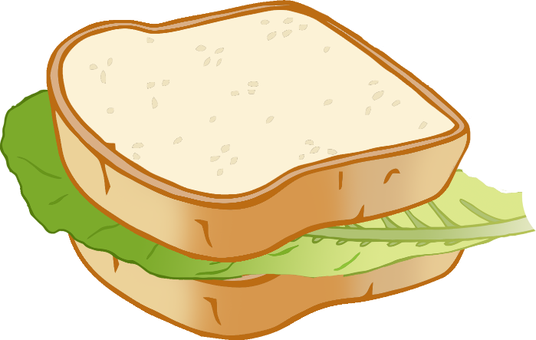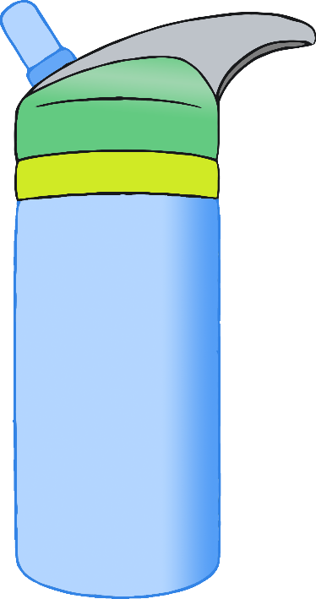

hurt

verletzt

(fur-lets-t)

English/German

© 2021 Little Owls Resources

unwell

unwohl

(on-vohl)

English/German

© 2021 Little Owls Resources

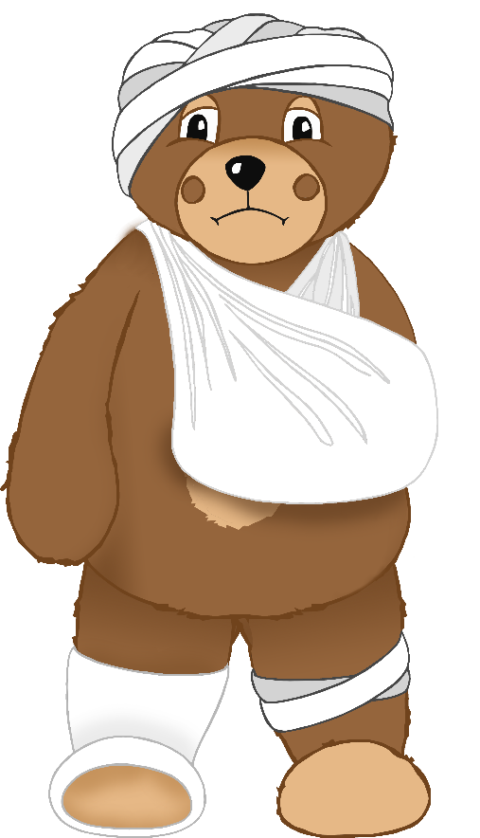

tired

müde

(moo-duh)

English/German

© 2021 Little Owls Resources

toilet

Toilette

(toy-lett-uh)

English/German

© 2021 Little Owls Resources

