English/French

© 2021 Little Owls Resources

no

non

(no)

said as ‘not’ without the t.

English/French

© 2021 Little Owls Resources

**✔️**

yes

oui

(wee)

hello

bonjour

(bon-joor)

English/French

© 2022 Little Owls Resources

goodbye

au revoir

(oh-rev-w-arr)

English/French

© 2022 Little Owls Resources

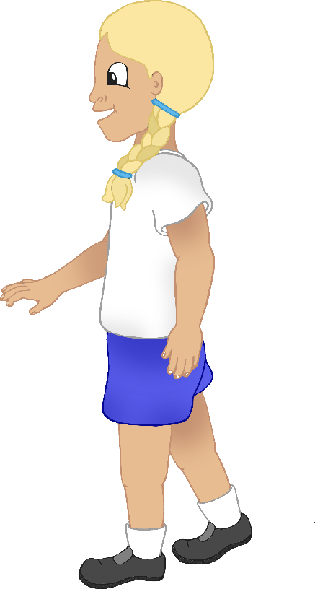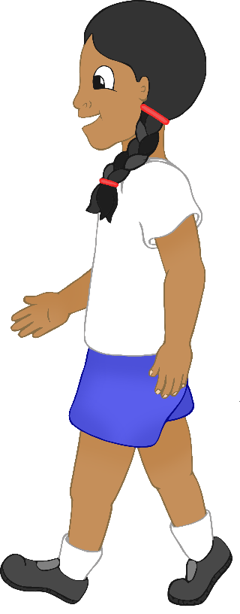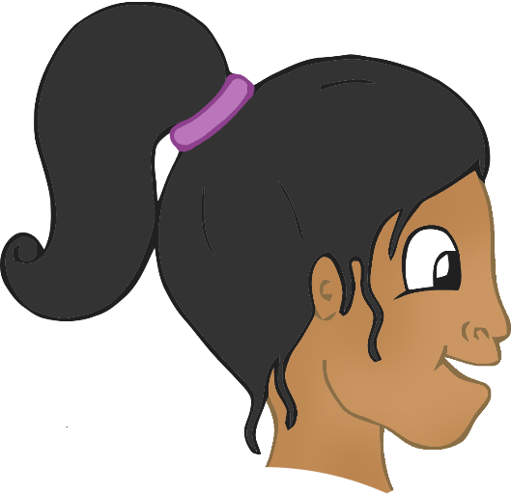

please

s'il vous plaît or s'il te plait

(sil-voo-play or sil-tuh-play)

English/French

© 2022 Little Owls Resources

thank-you

merci

(m-air-see)

English/French

© 2022 Little Owls Resources

mummy

maman

(mah-mo) ‘o’ as in b**o**x

English/French

© 2021 Little Owls Resources

daddy

papa

(papa)

English/French

© 2021 Little Owls Resources

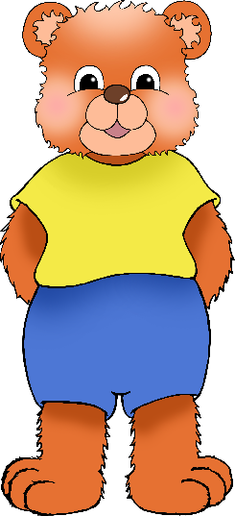

cuddle

câlin

(kal-uh)

English/French

© 2021 Little Owls Resources

play

jouer

(jzoo-ay)

English/French

/Portuguese

English/Portuguese

English/Portuguese

English/Portuguese

English/Portuguese

English/Portuguese

English/Portuguese

English/Portuguese

© 2021 Little Owls Resources

thirsty

soif

(swuff)

English/French

© 2021 Little Owls Resources

hungry

faim

(fuh)

English/French

© 2021 Little Owls Resources

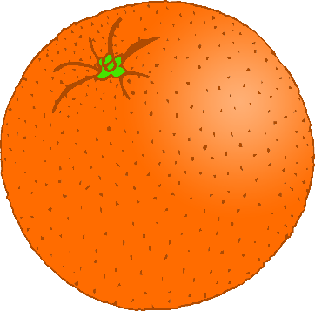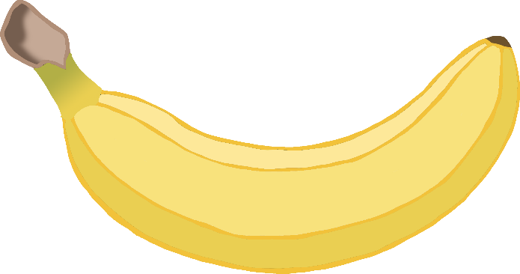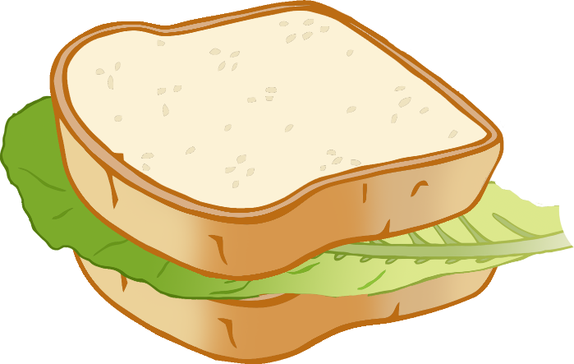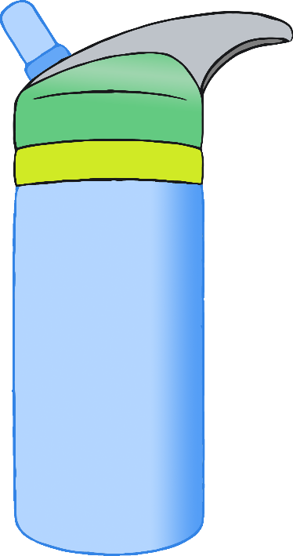

hurt

blessé

(bless-ay)

English/French

© 2021 Little Owls Resources

unwell

malade

(mal-add)

English/French

© 2021 Little Owls Resources

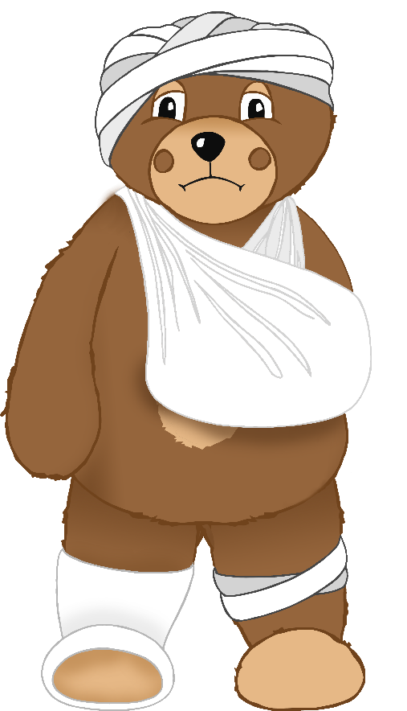

tired

fatigué

(fat-eeg-ay)

English/French

© 2021 Little Owls Resources

toilet

toilette

(twa-let)

English/French

© 2021 Little Owls Resources

