Key phrase prompts for:

Toilet

Hungry

Thirsty

Hurt

Unwell

Tired

Cuddle

Play Outdoors

Play Indoors

Yes

No

**Picture Communication Mat - Key Phrases**

© 2021 Little Owls Resources

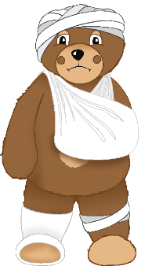

This mat can be used to aid non-verbal communication. It is intended for use by an adult or a child as a way of asking a question *(“Are you hungry?”)* or making a statement *(“I am hungry.”)*.

N.B. In teaching a child how to use this mat, it would be beneficial to initially show them real life objects that correspond to the pictures. For example, pointing to the ‘Thirsty’ picture while pointing at their drink cup to reinforce the link in their minds.

© 2021 Little Owls Resources

**Picture Communication Mat - Key Phrases**

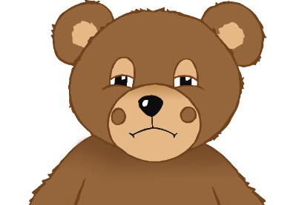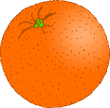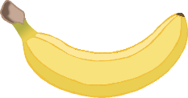

**✔️**

Play Indoors

Play Outdoors

Hungry

Thirsty

Cuddle

No

Yes

Tired

Unwell

Hurt

Toilet

© 2021 Little Owls Resources