**Picture Communication Fan - Key Phrases**

Key phrase prompts for:

Toilet

Hungry

Thirsty

Hurt

Unwell

Tired

Cuddle

Play Outdoors

Play Indoors

Yes

No

© 2021 Little Owls Resources

To create fan, cut and laminate each picture. Then join through the highlighted dot using a split pin or a treasury tag.

Once assembled these fans can be used to aid non-verbal communication. They are intended for use by an adult or a child as a way of asking a question *(“Are you hungry?”)* or making a statement *(“I am hungry.”)*.

N.B. In teaching a child how to use these cards, it would be beneficial to initially show them real life objects that correspond to the pictures. For example, holding up the ‘Thirsty’ card while pointing at their drink cup to reinforce the link in their minds.

© 2021 Little Owls Resources

© 2021 Little Owls Resources

© 2021 Little Owls Resources

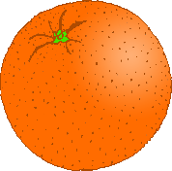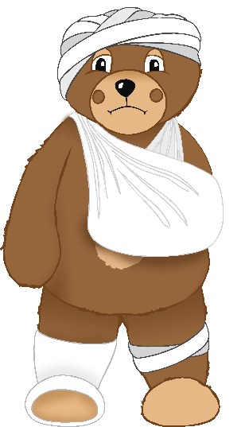

© 2021 Little Owls Resources

© 2021 Little Owls Resources

Toilet

Thirsty

Unwell

Hungry

Hurt

© 2021 Little Owls Resources

© 2021 Little Owls Resources

© 2021 Little Owls Resources

© 2021 Little Owls Resources

**✔️**

Play Indoors Outdoors

Play Outdoors

Yes

Cuddle

© 2021 Little Owls Resources

Tired

© 2021 Little Owls Resources

No