Key phrase prompts for:

Toilet

Hungry

Thirsty

Hurt

Unwell

Tired

Cuddle

Play Outdoors

Play Indoors

Yes

No

**Picture Communication Cards - Key Phrases**

© 2021 Little Owls Resources

These cards can be used to aid non-verbal communication. They are intended for use by an adult or a child as a way of asking a question *(“Are you hungry?”)* or making a statement *(“I am hungry.”)*.

N.B. In teaching a child how to use these cards, it would be beneficial to initially show them real life objects that correspond to the pictures. For example, holding up the ‘Thirsty’ card while pointing at their drink cup to reinforce the link in their minds.

The cards can be used individually or linked with a split pin through the grey circle.

© 2021 Little Owls Resources

Thirsty

© 2021 Little Owls Resources

Hurt

© 2021 Little Owls Resources

Toilet

© 2021 Little Owls Resources

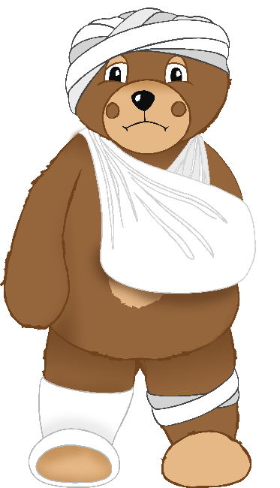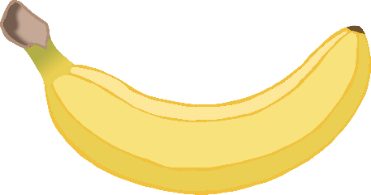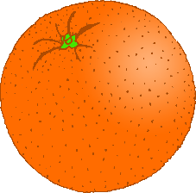

Hungry

© 2021 Little Owls Resources

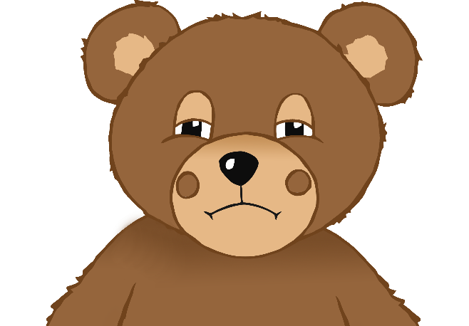

Unwell

© 2021 Little Owls Resources

Cuddle

© 2021 Little Owls Resources

Tired

© 2021 Little Owls Resources

Play Outdoors

© 2021 Little Owls Resources

**✔️**

Play Indoors

© 2021 Little Owls Resources

No

© 2021 Little Owls Resources

Yes

© 2021 Little Owls Resources