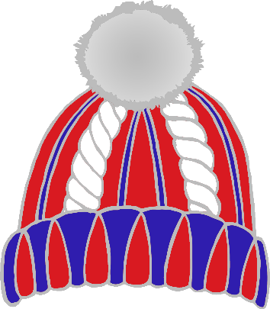

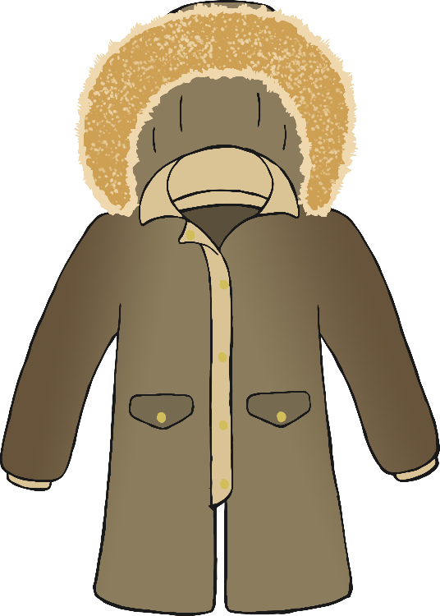

warm

Keeping

in

© 2022 Little Owls Resources

© 2022 Little Owls Resources

**Winter**