Junk Modelling Challenge Cards

Junk Modelling Challenge Cards

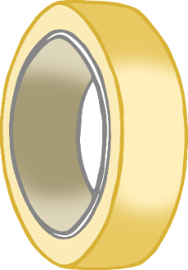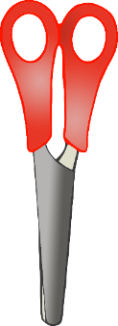

MAKE IT!



MAKE IT!

© 2022 Little Owls Resources

© 2022 Little Owls Resources

Can you make…

…a tree?

Can you make…

…a house?

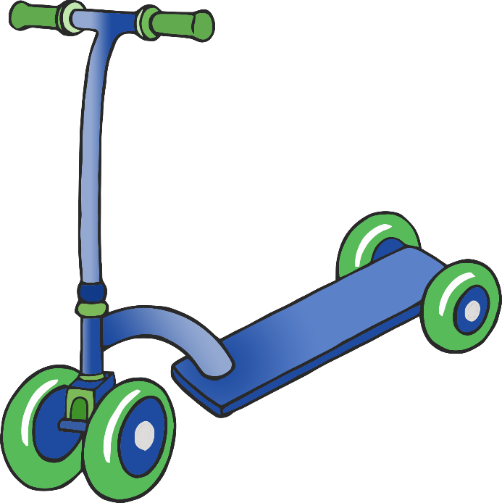



MAKE IT!



MAKE IT!

Junk Modelling Challenge Cards

© 2022 Little Owls Resources

Junk Modelling Challenge Cards

© 2022 Little Owls Resources

Can you make…

…a post box?

Can you make…

…a scooter?

Junk Modelling Challenge Cards

Junk Modelling Challenge Cards



MAKE IT!



MAKE IT!

© 2022 Little Owls Resources

© 2022 Little Owls Resources

Can you make…

…a brachiosaurus?

Can you make…

…a bus?

Junk Modelling Challenge Cards

Junk Modelling Challenge Cards



MAKE IT!



MAKE IT!

© 2022 Little Owls Resources

© 2022 Little Owls Resources

Can you make…

…a train?

Can you make…

…a stegosaurus?

Junk Modelling Challenge Cards

Junk Modelling Challenge Cards



MAKE IT!



MAKE IT!

© 2022 Little Owls Resources

© 2022 Little Owls Resources

Can you make…

…a tyrannosaurus rex?

Can you make…

…a lorry?

Junk Modelling Challenge Cards

Junk Modelling Challenge Cards



MAKE IT!



MAKE IT!

© 2022 Little Owls Resources

© 2022 Little Owls Resources

Can you make…

…a car?

Can you make…

…a bridge?

Junk Modelling Challenge Cards

Junk Modelling Challenge Cards



MAKE IT!



MAKE IT!

© 2022 Little Owls Resources

© 2022 Little Owls Resources

Can you make…

…a toothbrush?

Can you make…

…a motorbike?

Junk Modelling Challenge Cards

Junk Modelling Challenge Cards



MAKE IT!



MAKE IT!

© 2022 Little Owls Resources

© 2022 Little Owls Resources

Can you make…

…an aeroplane?

Can you make…

…a snail?

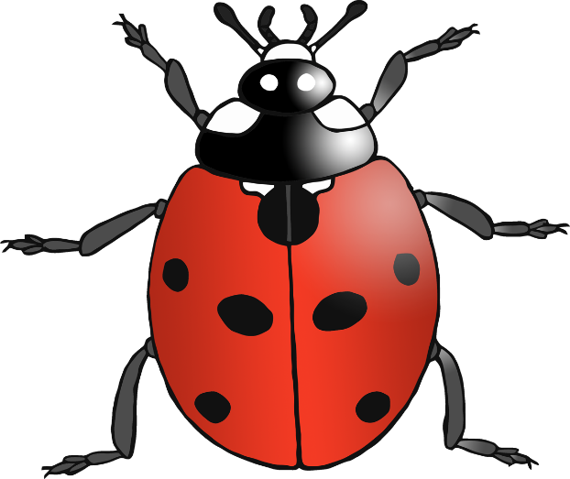

Junk Modelling Challenge Cards

Junk Modelling Challenge Cards



MAKE IT!



MAKE IT!

© 2022 Little Owls Resources

© 2022 Little Owls Resources

Can you make…

…a ladybird?

Can you make…

…a spaceship?

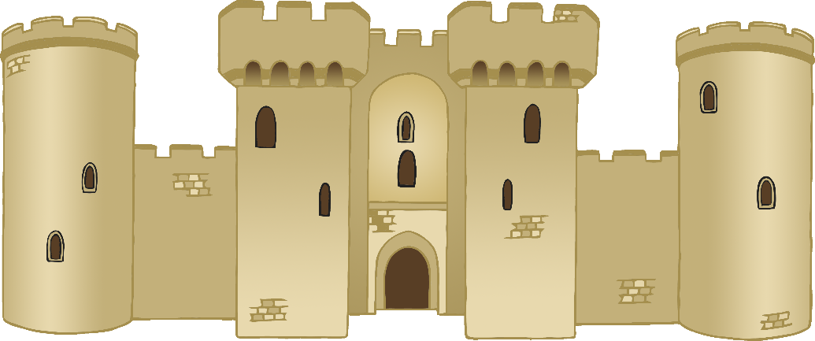

Junk Modelling Challenge Cards

Junk Modelling Challenge Cards



MAKE IT!



MAKE IT!

© 2022 Little Owls Resources

© 2022 Little Owls Resources

Can you make…

…a castle?

Can you make…

…a birthday cake?