Cow

Jack

Jack’s Mum

© 2021 Little Owls Resources

© 2021 Little Owls Resources

© 2021 Little Owls Resources

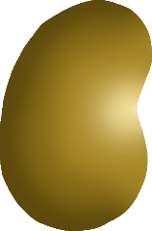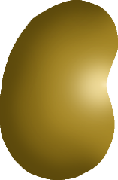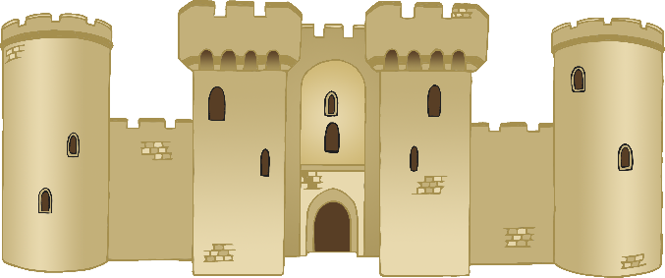

Magic Beans

© 2021 Little Owls Resources

© 2021 Little Owls Resources

© 2021 Little Owls Resources

Beanstalk

Castle

Axe

© 2021 Little Owls Resources

© 2021 Little Owls Resources

© 2021 Little Owls Resources

Hen

Giant

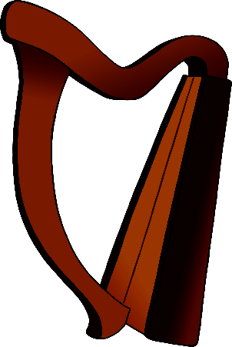

Gold Coins

Harp

© 2021 Little Owls Resources

© 2021 Little Owls Resources

Golden Egg

© 2021 Little Owls Resources

cow

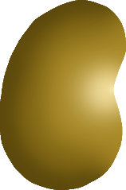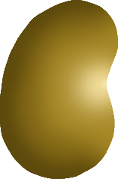

beanstalk

magic beans

© 2021 Little Owls Resources

© 2021 Little Owls Resources

© 2021 Little Owls Resources

axe

castle

© 2021 Little Owls Resources

© 2021 Little Owls Resources

© 2021 Little Owls Resources

giant

gold coins

golden egg

© 2021 Little Owls Resources

© 2021 Little Owls Resources

© 2021 Little Owls Resources

hen



harp

© 2021 Little Owls Resources