© 2021 Little Owls Resources

Beanstalk

Castle

Cow

**Jack and the Beanstalk Word Mat**

Hen

Jack

Golden Egg

Gold Coins

Axe

Harp

Jack’s Mum

Giant

Magic Beans

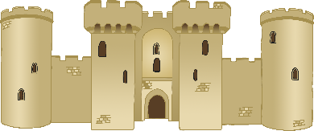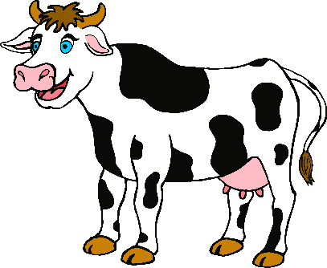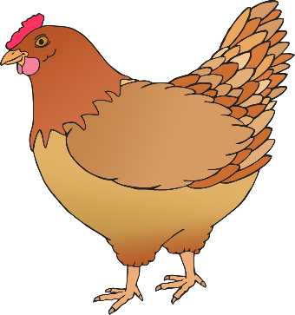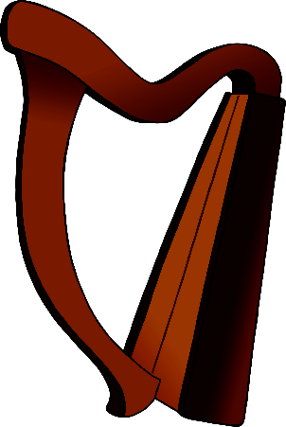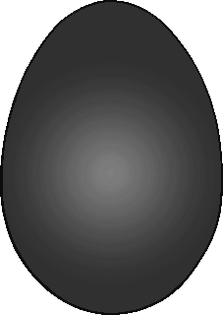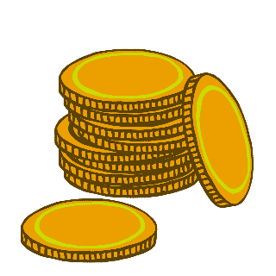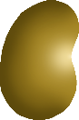

© 2021 Little Owls Resources

beanstalk

castle

cow

**Jack and the Beanstalk Word Mat**

hen

Jack

golden egg

gold coins

axe

harp

Jack’s Mum

giant

magic beans

