**What happens next?**

These sheets can be used to consolidate the children’s knowledge of the story. The child can draw what they remember happening next in the lower box.

To extend older children, labels/descriptions via emergent writing could be encouraged.

Have fun!

© 2021 Little Owls Resources

The magic beans are thrown away…

© 2021 Little Owls Resources

**What happens next?**

Jack sees that an enormous beanstalk has grown…

© 2021 Little Owls Resources

**What happens next?**

Jack climbed to the top of the beanstalk…

© 2021 Little Owls Resources

**What happens next?**

The wolf is standing outside the straw house…

© 2021 Little Owls Resources

**What happens next?**

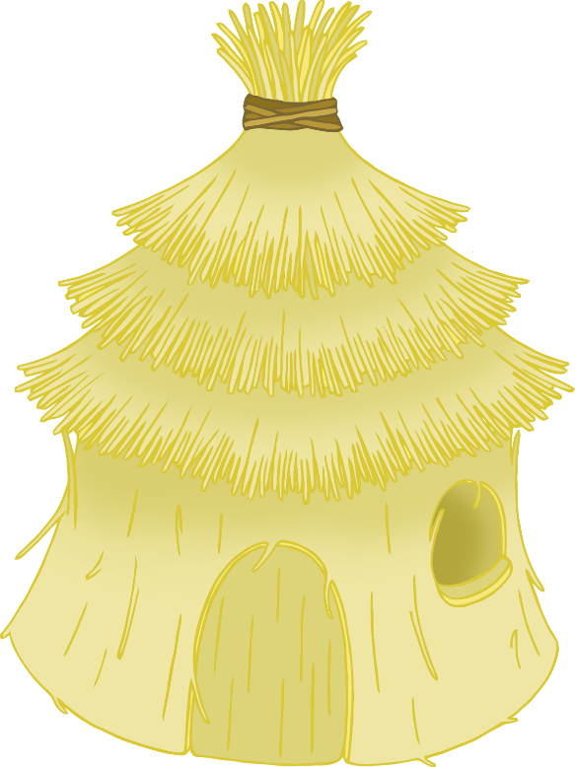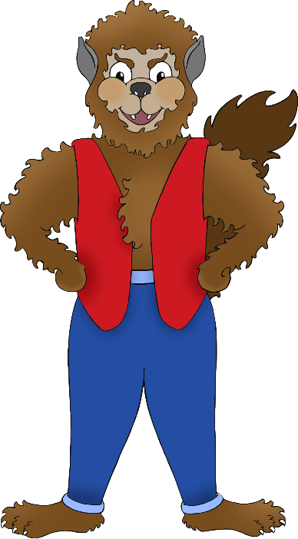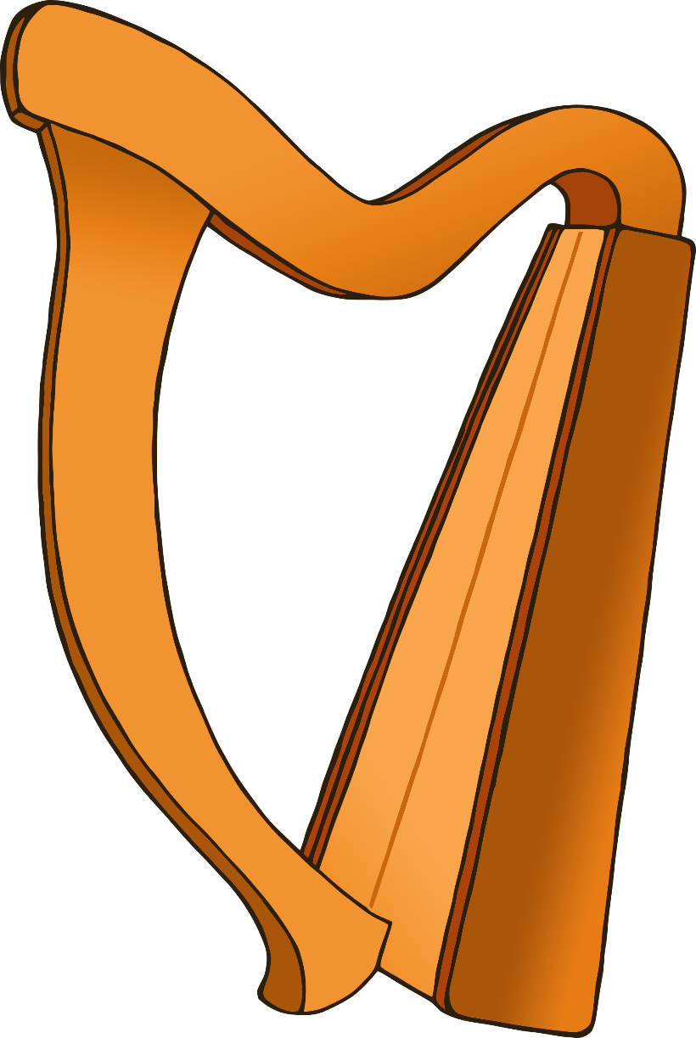

Jack sees a harp that can play music by itself…

© 2021 Little Owls Resources

**What happens next?**

The giant sees Jack stealing the harp…

© 2021 Little Owls Resources

**What happens next?**

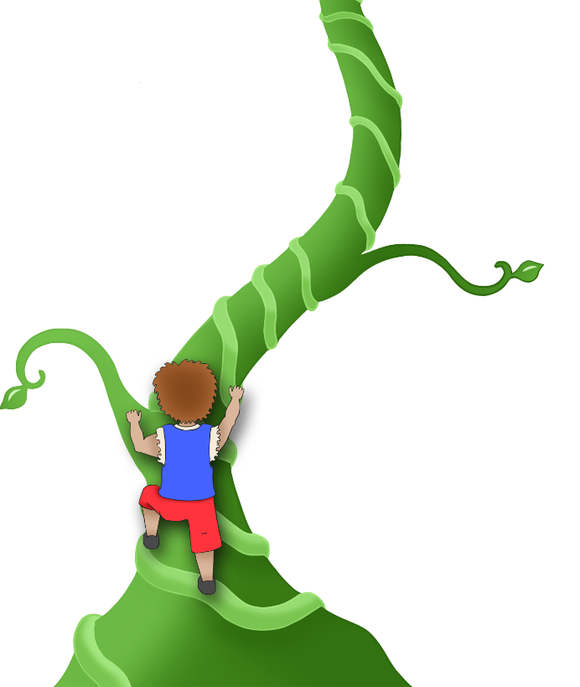

Jack climbs down the beanstalk…

© 2021 Little Owls Resources

**What happens next?**