Jack and his mother were poor. Jack went to the market to sell their cow.

© 2021 Little Owls Resources

When Jack came back with magic beans his mother threw them away.

© 2021 Little Owls Resources



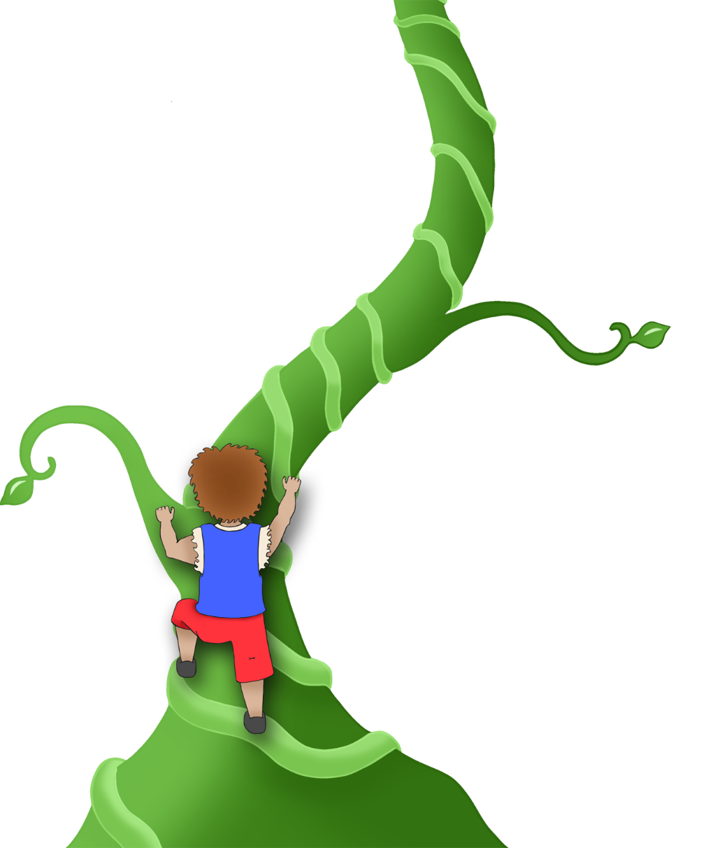

The beans grew and grew into an enormous beanstalk. Jack decided to climb it.

© 2021 Little Owls Resources

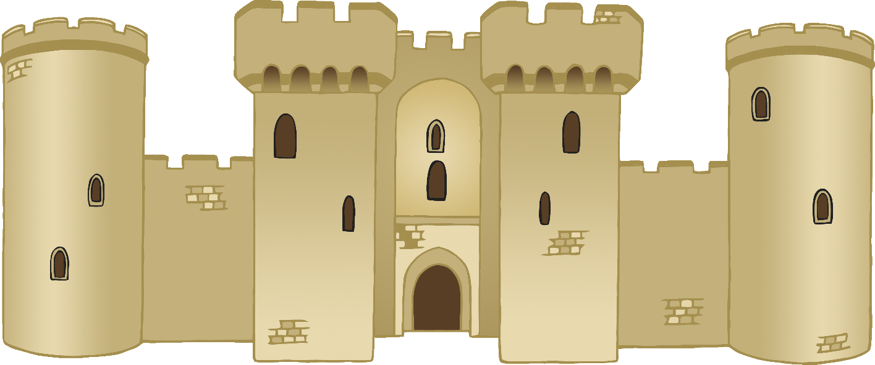

At the top of the beanstalk Jack found a huge castle sitting in the clouds.

© 2021 Little Owls Resources

Jack found a hen that laid golden eggs and a great big bag of gold coins!

© 2021 Little Owls Resources

Jack came back again and took the magic harp that played by itself.

© 2021 Little Owls Resources

“Fee Fi Fo Fum!” the angry giant said. He chased after Jack.

© 2021 Little Owls Resources

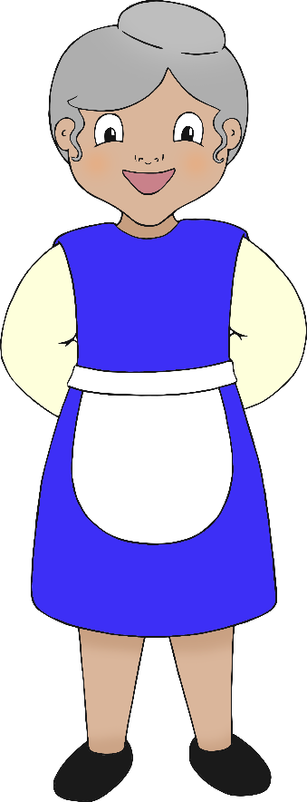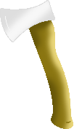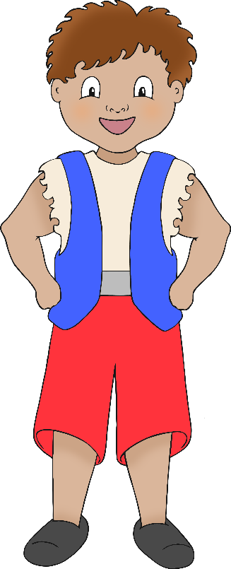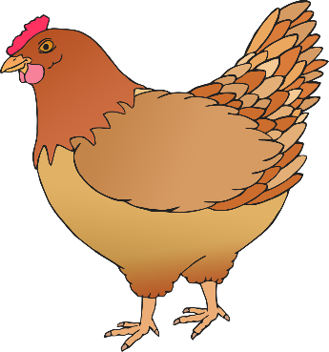

Jack ran back home and then chopped down the beanstalk with an axe.

Jack and his mother lived happily ever after.

© 2021 Little Owls Resources