Jack

© 2020 Little Owls Resources

© 2020 Little Owls Resources

Jack

Jack

© 2020 Little Owls Resources

© 2020 Little Owls Resources

Jack

Jack’s Mum

© 2020 Little Owls Resources

© 2020 Little Owls Resources

Jack’s Mum

Jack’s Mum

© 2020 Little Owls Resources

© 2020 Little Owls Resources

Jack’s Mum

Cow

© 2020 Little Owls Resources

© 2020 Little Owls Resources

Cow

Cow

© 2020 Little Owls Resources

© 2020 Little Owls Resources

Cow

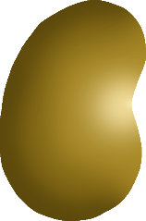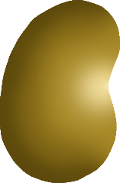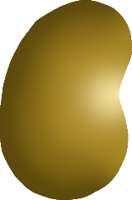

Magic Beans

© 2020 Little Owls Resources

© 2020 Little Owls Resources

Magic Beans



Magic Beans

© 2020 Little Owls Resources

Owls Resources

© 2020 Little Owls Resources

Magic Beans

Beanstalk

© 2020 Little Owls Resources

© 2020 Little Owls Resources

Beanstalk

Beanstalk

© 2020 Little Owls Resources

© 2020 Little Owls Resources

Beanstalk

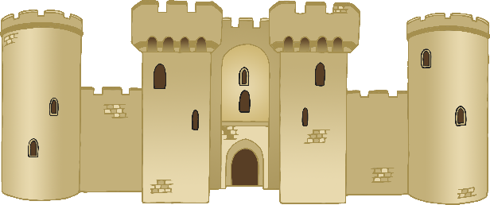

Castle

© 2020 Little Owls Resources

© 2020 Little Owls Resources

© 2020 Little Owls Resources

Castle

Castle

© 2020 Little Owls Resources

© 2020 Little Owls Resources

Castle

Giant

© 2020 Little Owls Resources

© 2020 Little Owls Resources

Giant

Giant

© 2020 Little Owls Resources

© 2020 Little Owls Resources

Giant

Axe

© 2020 Little Owls Resources

© 2020 Little Owls Resources

Axe

Axe

© 2020 Little Owls Resources

© 2020 Little Owls Resources

Owls Resources

Axe

Hen

© 2020 Little Owls Resources

© 2020 Little Owls Resources

Hen

Hen

© 2020 Little Owls Resources

© 2020 Little Owls Resources

Hen

Golden Egg

© 2020 Little Owls Resources

© 2020 Little Owls Resources

Golden Egg

Golden Egg

© 2020 Little Owls Resources

© 2019 Little Owls Resources

Golden Egg

© 2020 Little Owls Resources

Gold Coins

© 2020 Little Owls Resources

© 2019 Little Owls Resources

Gold Coins

© 2020 Little Owls Resources

Gold Coins

© 2020 Little Owls Resources

© 2019 Little Owls Resources

Gold Coins

© 2020 Little Owls Resources

Harp

© 2020 Little Owls Resources

© 2019 Little Owls Resources

Harp

© 2020 Little Owls Resources

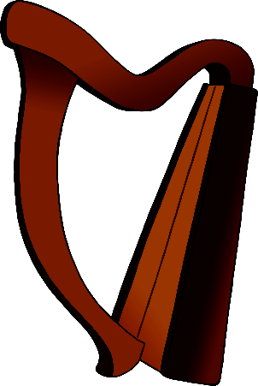

Harp

© 2020 Little Owls Resources

© 2019 Little Owls Resources

Harp

© 2020 Little Owls Resources