© 2021 Little Owls Resources

**My Favourite Part**

Jack and the Beanstalk

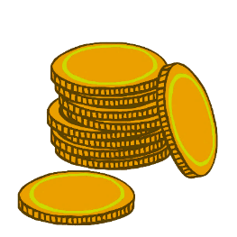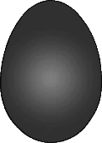

____________________________________________________________________________________

© 2021 Little Owls Resources

**My Favourite Part**

Jack and the Beanstalk



© 2021 Little Owls Resources

**My Favorite Part**

Jack and the Beanstalk



____________________________________________________________________________________

© 2021 Little Owls Resources

**My Favorite Part**

Jack and the Beanstalk

