**Jack and the Beanstalk**

**The Giant’s Castle**

**Magic Beans**

**Jack**

**Jack’s**

**Mum**

**Giant**

**Beanstalk**

**The Magic Harp**

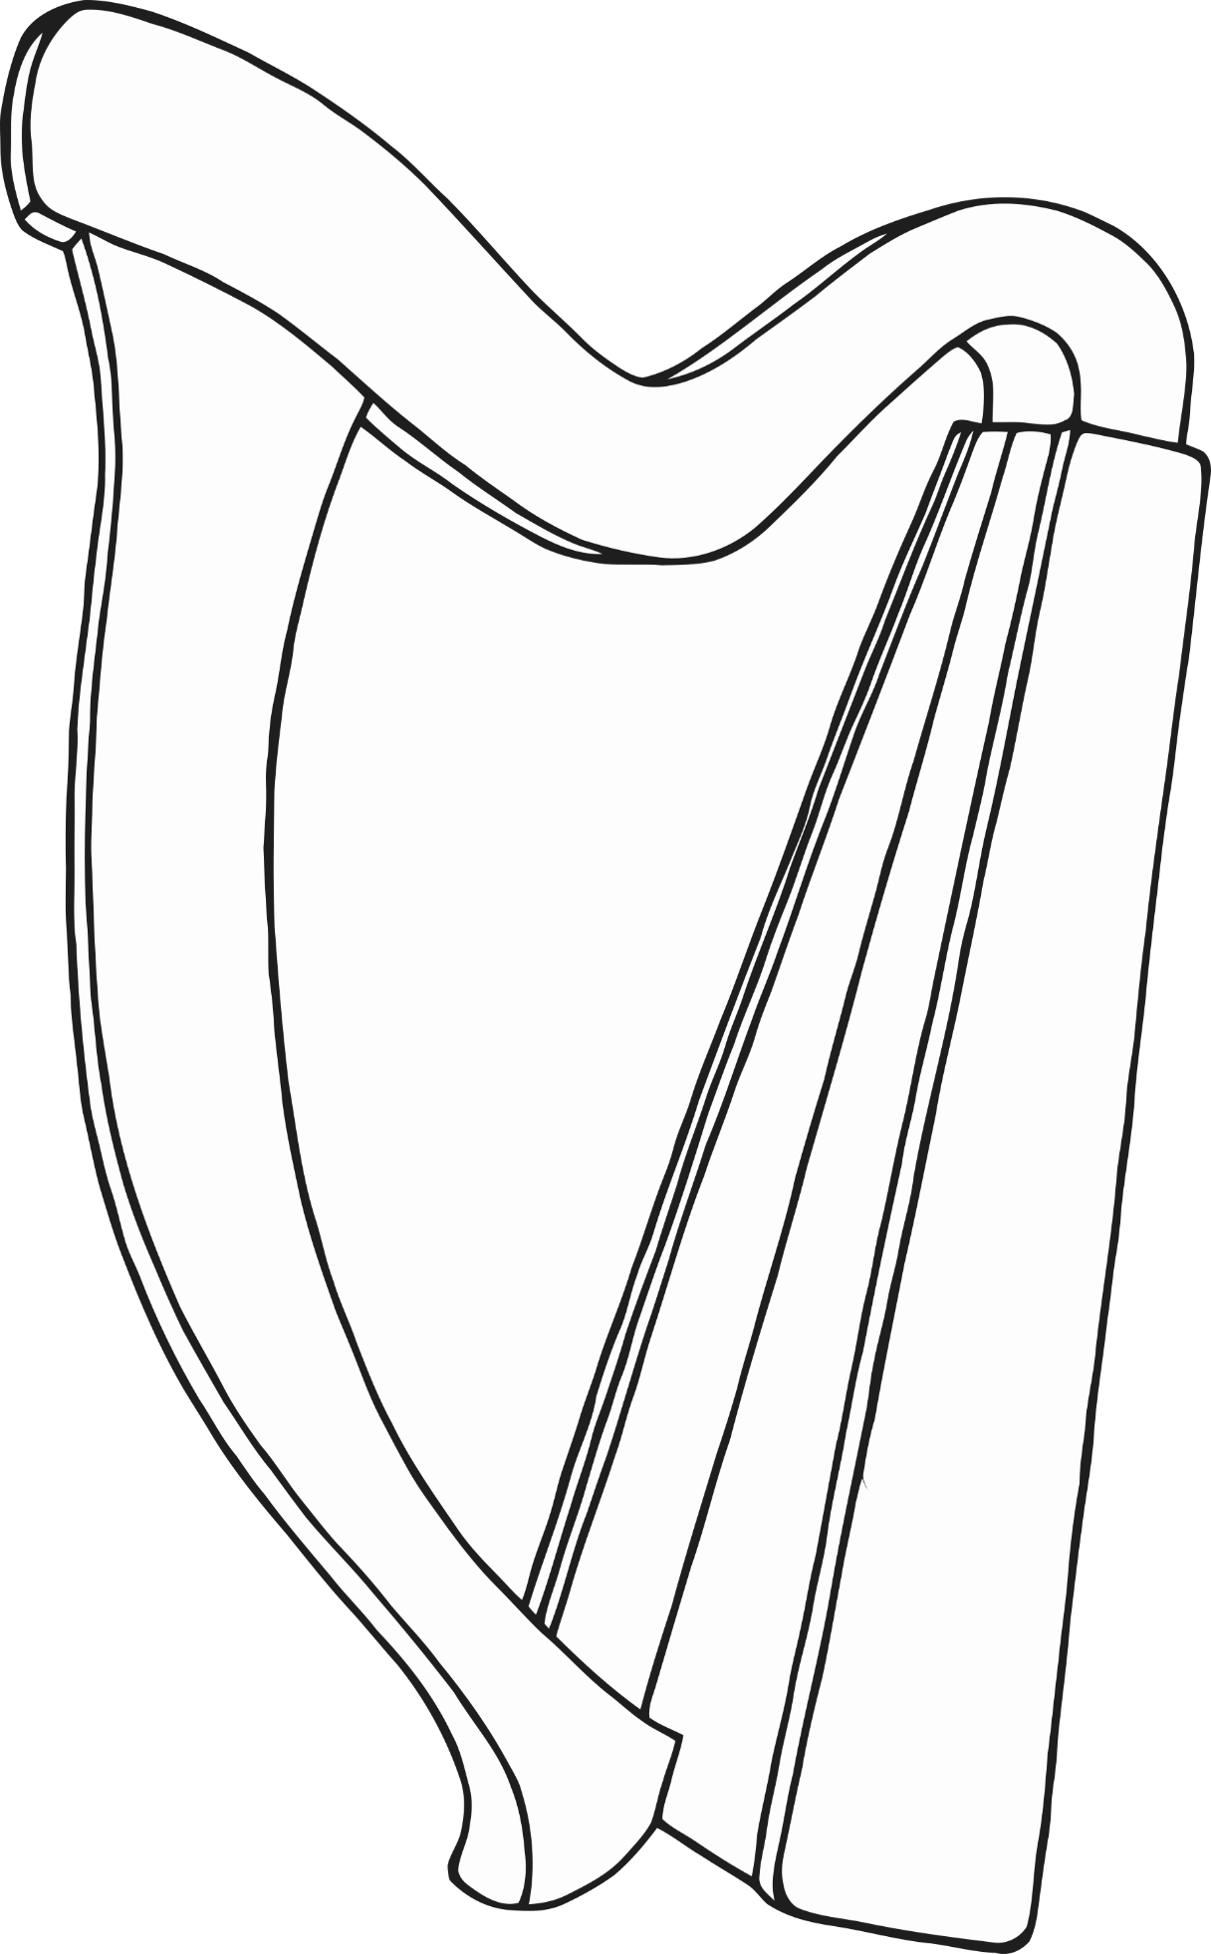

**Hen and Golden Eggs**

