These sheets are made for children to think about the characters from the story and record their thoughts.

These thoughts can be written around the pictures by the children if they are able but equally valuable if scribed by an adult.

The discussions and ideas are the most important part of this activity!

Character Description Sheets

© 2021 Little Owls Resources

At the end of the pack is a short question idea card to get the discussion started but add as many other questions as you like and encourage the children to ask their own questions too!

**Character Description – Jack and the Beanstalk**

© 2021 Little Owls Resources

**Character Description – Jack and the Beanstalk**

© 2021 Little Owls Resources

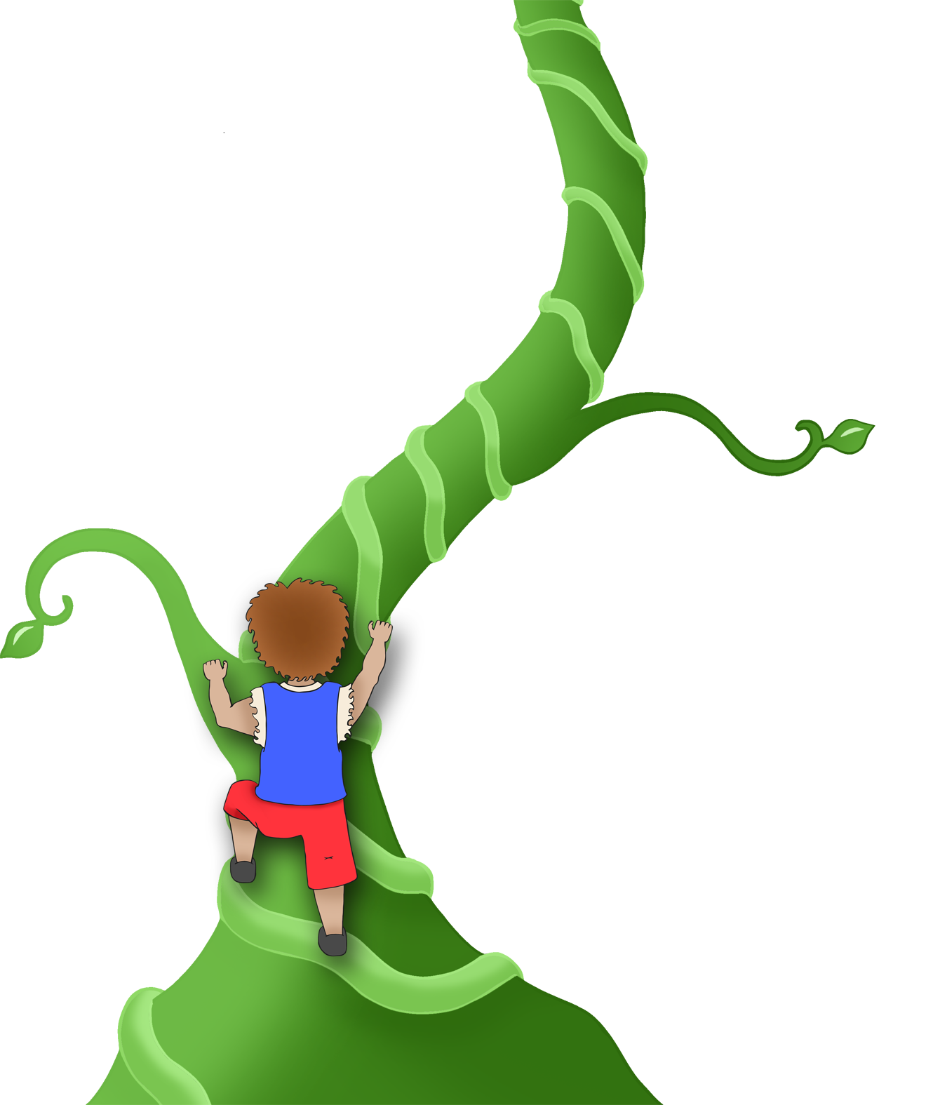

**Character Description – Jack and the Beanstalk**

© 2021 Little Owls Resources

**Character Description – Jack and the Beanstalk**

© 2021 Little Owls Resources

**Character Description – Jack and the Beanstalk**

© 2021 Little Owls Resources

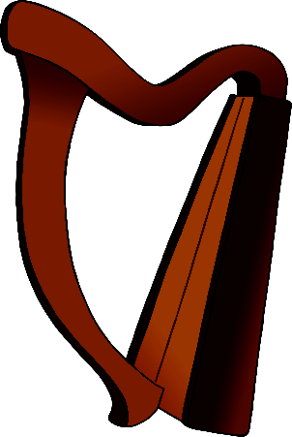

What is (character name) doing in this picture?

How do you think (character name) feels at this point in the story?

What do you think (character name) is saying in the picture?

What happens to (character name) next?

How would you describe (character name)? Kind? Nasty? Clever? Silly?

Why?

**Character Description Question Ideas**

© 2021 Little Owls Resources