**Jack**

**and the**

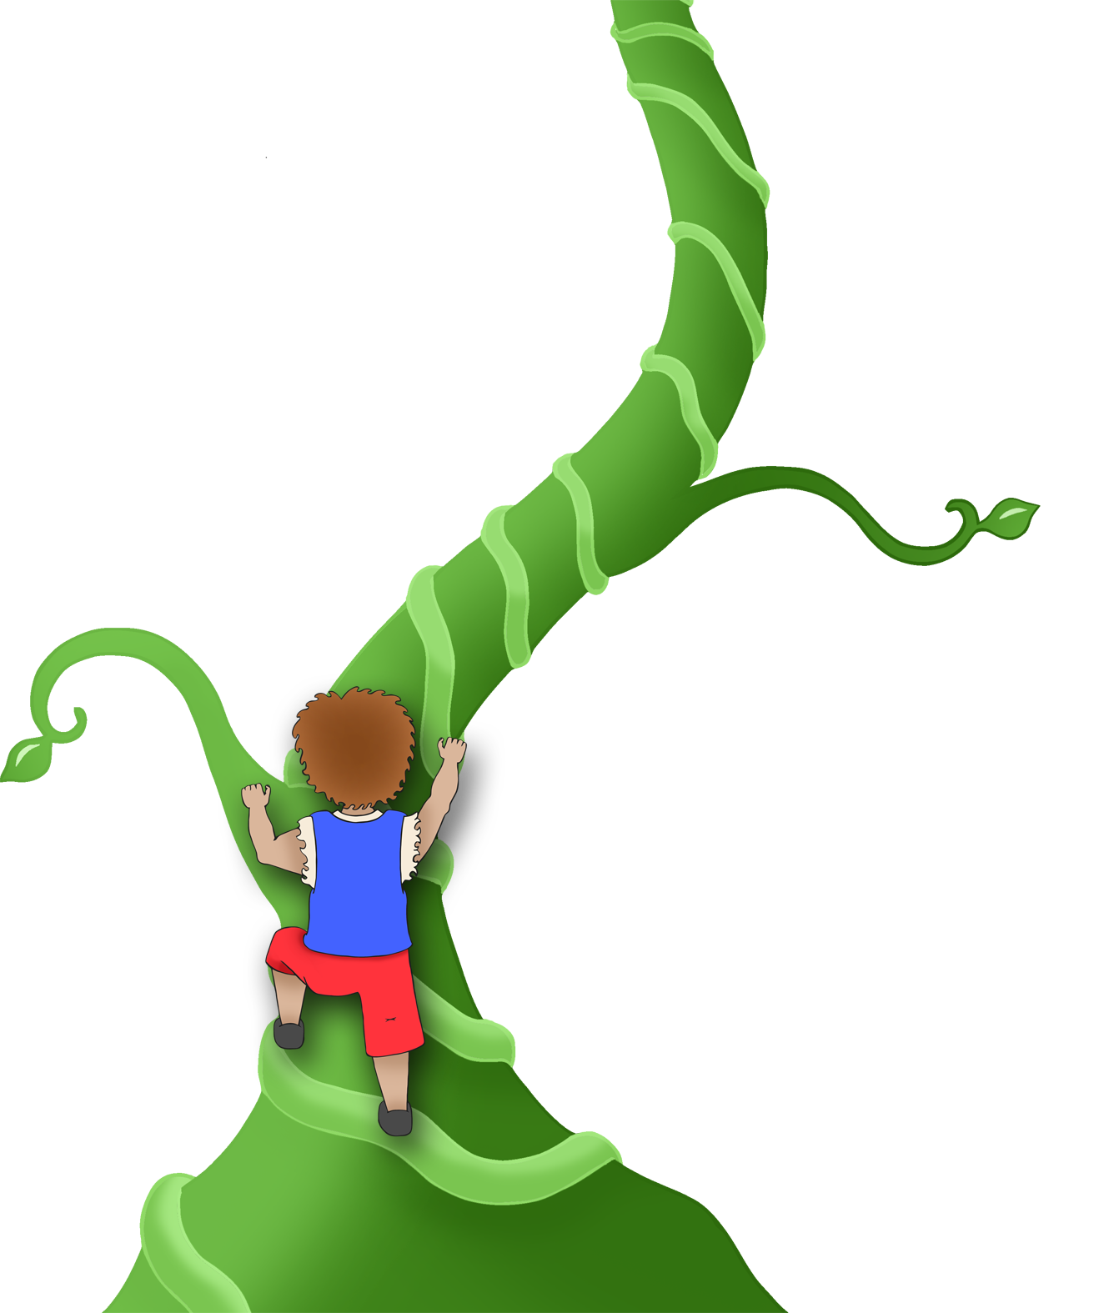

**Beanstalk**

© 2020 Little Owls Resources

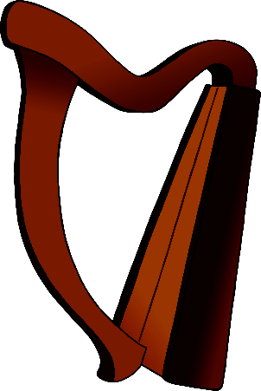

Fee! Fi! Fo! Fum!

Fee! Fi! Fo! Fum!