1

**Jack and the Beanstalk**

**Activity Challenge!**

(left arm – right arm)

**Throw! Throw! Throw!**

Throw the magic beans away!

**Walk – Walk – Pull!**

Lead the cow to the market. Don’t let go of the harness!

**Jack and the Beanstalk**

**Activity Challenge!**

© 2021 Little Owls Resources

2

© 2021 Little Owls Resources

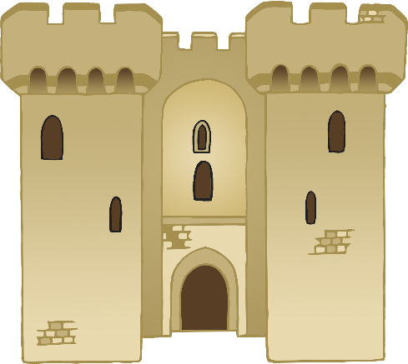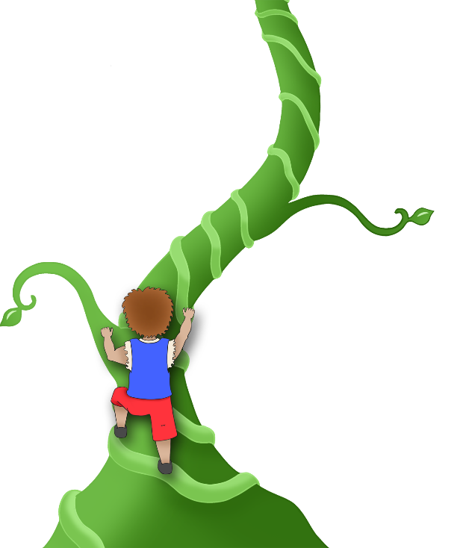

(lift arms and legs)

**Climb! Climb! Climb!**

**Tiptoe! Tiptoe!**

Shh!

Tiptoe quietly through the enormous castle!

Climb the beanstalk!

© 2021 Little Owls Resources

**Jack and the Beanstalk**

**Activity Challenge!**

**Jack and the Beanstalk**

**Activity Challenge!**

3

4

© 2021 Little Owls Resources

5

The giant has seen us!

**RUN!**

(on the spot)

Lift the HEAVY bag of gold!

**1, 2, 3… LIFT!**

**Jack and the Beanstalk**

**Activity Challenge!**

**Jack and the Beanstalk**

**Activity Challenge!**

© 2021 Little Owls Resources

© 2021 Little Owls Resources

6

**Chop! Chop!**

Chop the beanstalk down!

**Stomp! Stomp!**

The giant’s feet stomp as he runs.

**Jack and the Beanstalk**

**Activity Challenge!**

**Jack and the Beanstalk**

**Activity Challenge!**

7

© 2021 Little Owls Resources

© 2021 Little Owls Resources

8