Nursery Rhymes

Jack and Jill

© 2023 Little Owls Resources

* Sequence cards (5)
* Cut & match sequence cards (2)
* Illustration activity sheets (4)
* Landscape lyrics poster (1)
* Landscape lyrics poster – colouring (1)
* A6 lyrics sheets (1)
* Jack and Jill colouring sheet (1)

This pack includes:

(Number of A4 pages in brackets)

© 2023 Little Owls Resources

Jack and Jill went up the hill…

© 2023 Little Owls Resources

…to fetch a pail of water.

Jack fell down and broke his crown...

© 2023 Little Owls Resources

© 2023 Little Owls Resources

…and Jill came tumbling after.

© 2023 Little Owls Resources

© 2023 Little Owls Resources

© 2023 Little Owls Resources

© 2023 Little Owls Resources

© 2023 Little Owls Resources

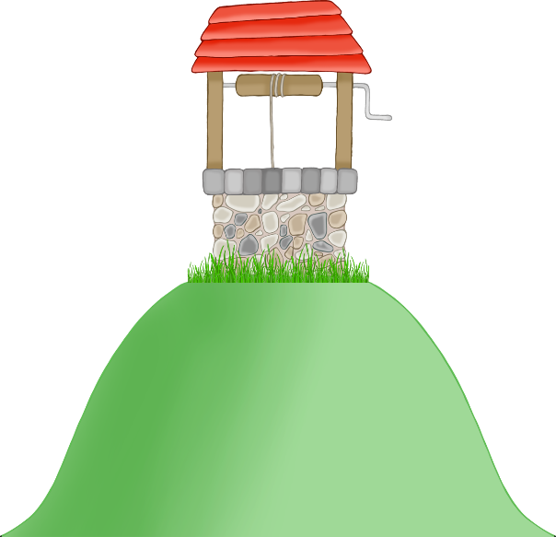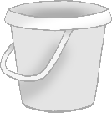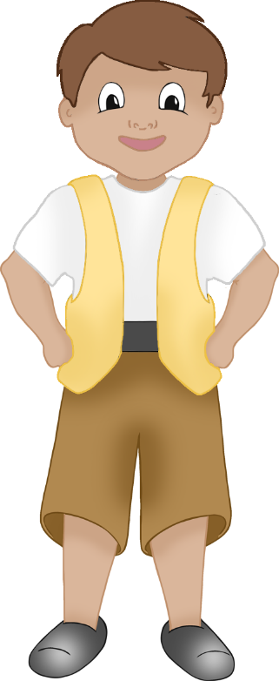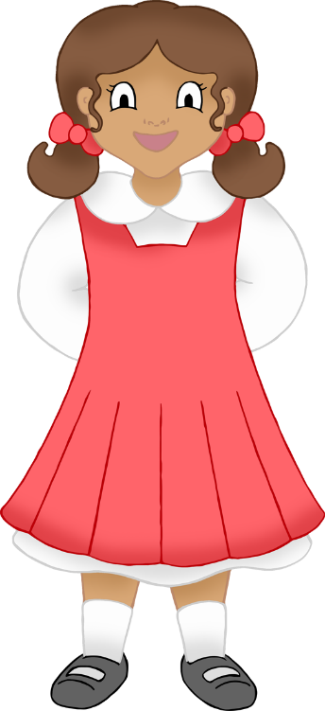

Jack and Jill went up the hill…

© 2023 Little Owls Resources

…to fetch a pail of water.

© 2023 Little Owls Resources

Jack fell down and broke his crown...

© 2023 Little Owls Resources

…and Jill came tumbling after.

© 2023 Little Owls Resources

© 2023 Little Owls Resources

Jack and Jill went up the hill to fetch a pail of water.

Jack and Jill

Illustration Activity

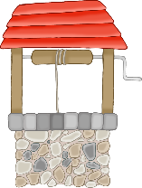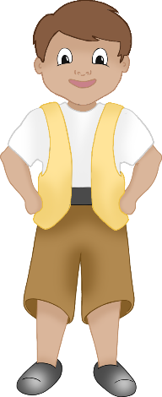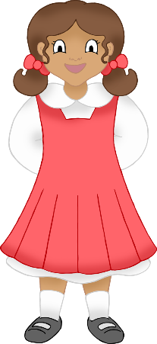

© 2023 Little Owls Resources

Jack fell down and broke his crown…

Jack and Jill

Illustration Activity



© 2023 Little Owls Resources

…and Jill came tumbling after.

Jack and Jill

Illustration Activity



© 2023 Little Owls Resources

Jack and Jill

Illustration Activity



© 2023 Little Owls Resources

Jack and Jill went up the hill

to fetch a pail of water.

Jack fell down and broke his crown,

and Jill came tumbling after.

Jack and Jill

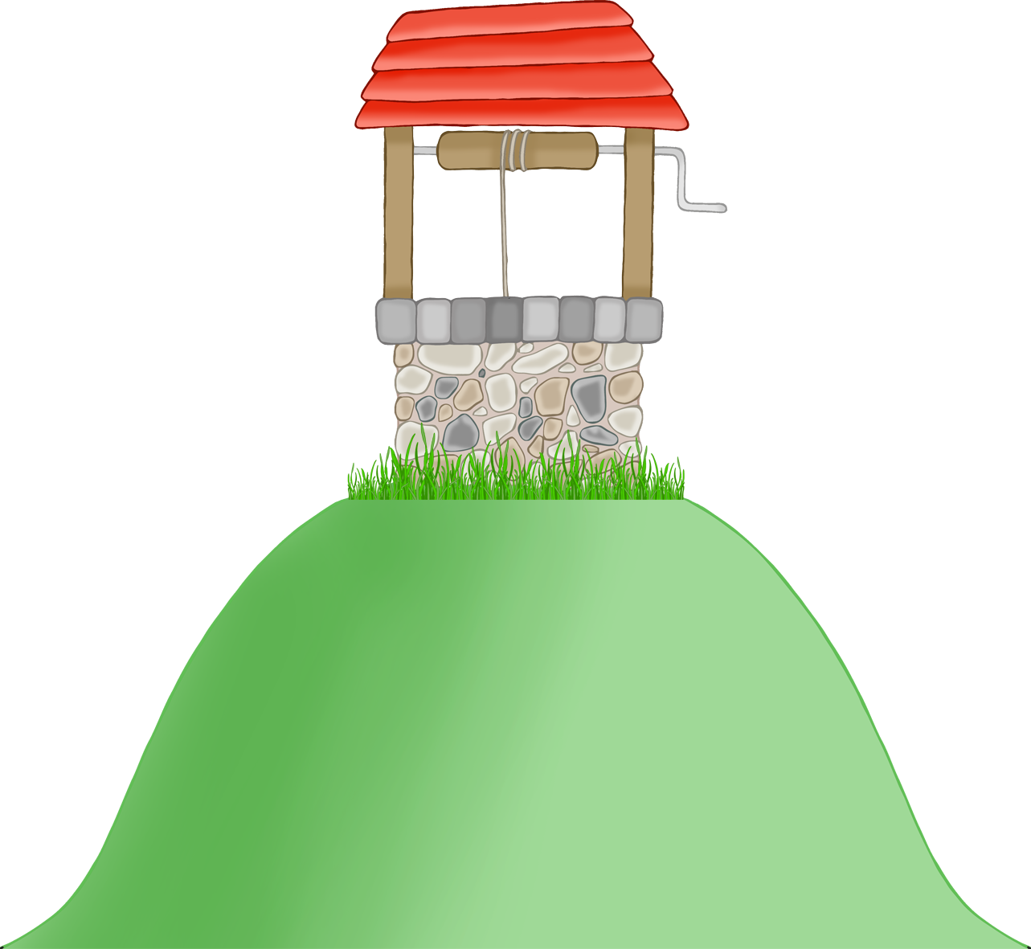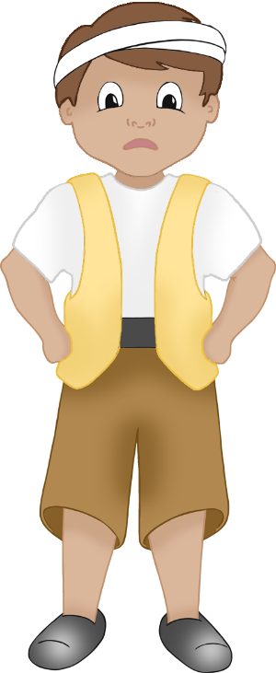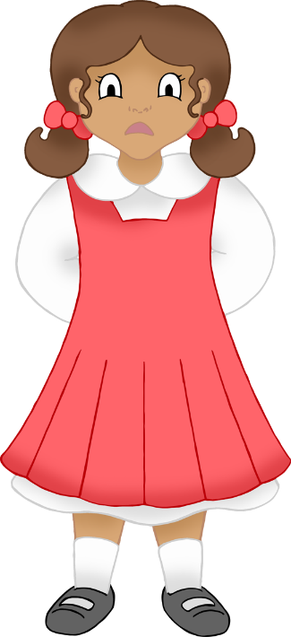

Jack and Jill went up the hill

to fetch a pail of water.

Jack fell down and broke his crown,

and Jill came tumbling after.

Jack and Jill

© 2023 Little Owls Resources

© 2023 Little Owls Resources

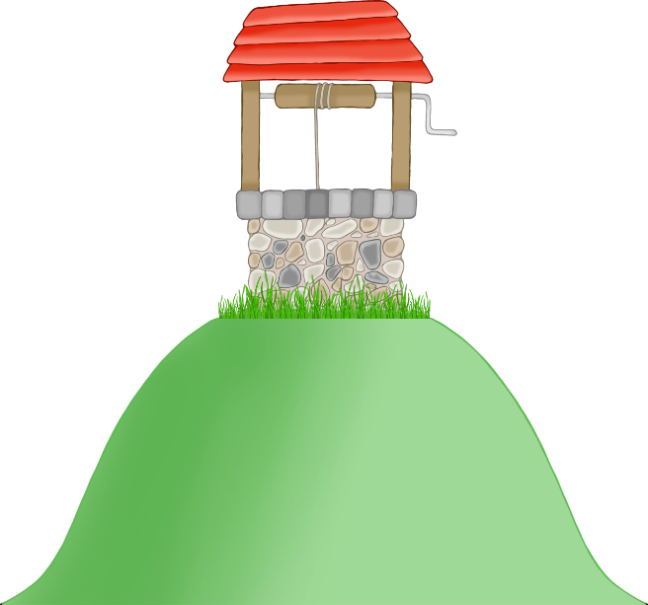

Jack and Jill

Jack and Jill went up the hill

to fetch a pail of water.

Jack fell down and broke his crown,

and Jill came tumbling after.

© 2023 Little Owls Resources



Jack and Jill

Jack and Jill went up the hill

to fetch a pail of water.

Jack fell down and broke his crown,

and Jill came tumbling after.

© 2023 Little Owls Resources



Jack and Jill

Jack and Jill went up the hill

to fetch a pail of water.

Jack fell down and broke his crown,

and Jill came tumbling after.

© 2023 Little Owls Resources

Jack and Jill