Inventions

Television

© 2020 Little Owls Resources

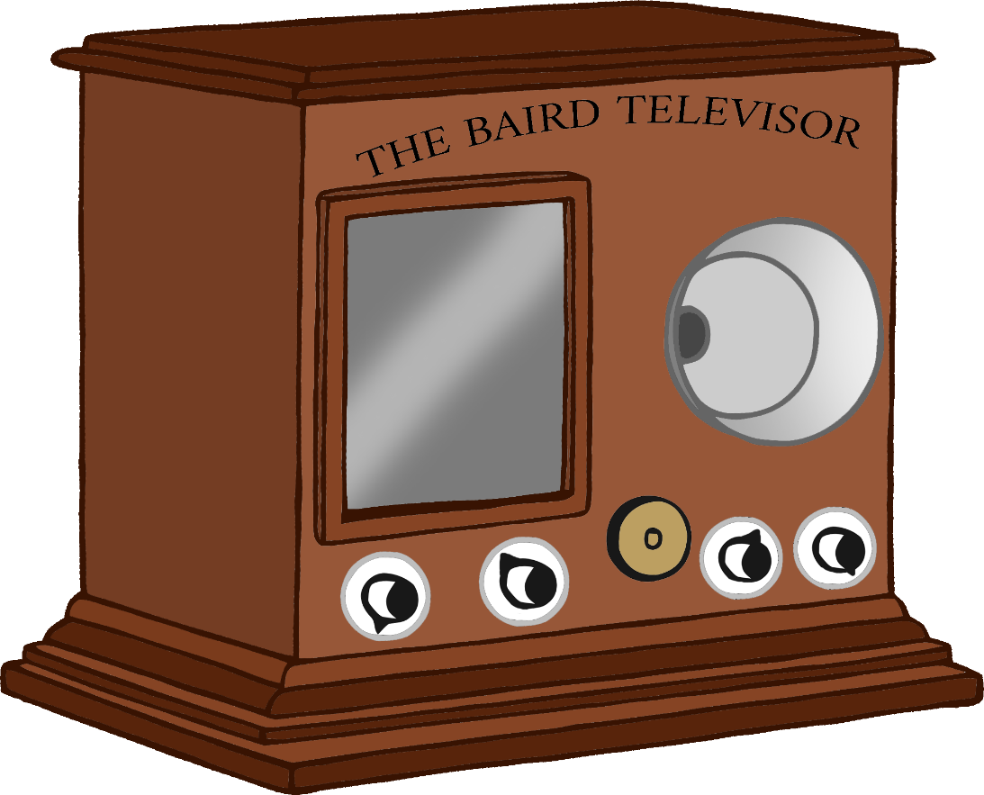

Inventor: John Logie Baird (Scottish)

Year: 1925

Inventions

Car

© 2020 Little Owls Resources

Inventor: Karl Benz (German)

Year: 1885

Inventions

Life Raft

© 2020 Little Owls Resources

Inventor: Maria Beasley (American)

Year: 1882

Inventions

Light Bulb

© 2020 Little Owls Resources

Inventor: Thomas Edison (American)

Year: 1879