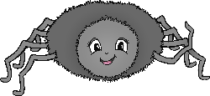

Incy Wincy Spider climbed up the waterspout.

www.littleowls-premium.com © 2019 Little Owls Resources

**up**

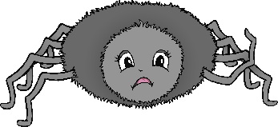

Down came the rain and washed the spider out.

www.littleowls-premium.com © 2019 Little Owls Resources

Out came the sun and dried up all the rain.

www.littleowls-premium.com © 2019 Little Owls Resources

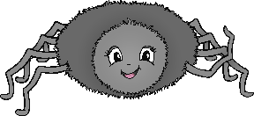

So, Incy Wincy Spider climbed up the spout again.

www.littleowls-premium.com © 2019 Little Owls Resources

**up**



Itsy Bitsy Spider climbed up the waterspout.

www.littleowls-premium.com © 2019 Little Owls Resources

**up**

Down came the rain and washed the spider out.

www.littleowls-premium.com © 2019 Little Owls Resources

Out came the sun and dried up all the rain.

www.littleowls-premium.com © 2019 Little Owls Resources

So, Itsy Bitsy Spider climbed up the spout again.

www.littleowls-premium.com © 2019 Little Owls Resources

**up**