Incy Wincy (Itsy Bitsy) Spider

Lollipop Puppets

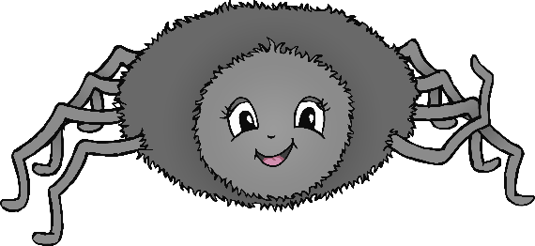



N.B.

On the lollipop stick, put the sun back to back with the rain cloud. That way it can be easily flipped from sun to rain during the re-telling of the rhyme.

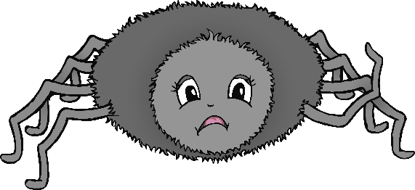

N.B.

On the lollipop stick, put a happy spider back to back with a sad spider. That way it can be easily flipped from happy to sad during the re-telling of the rhyme.