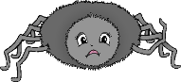

© 2019 Little Owls Resources

© 2019 Little Owls Resources

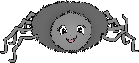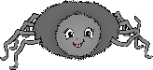

© 2019 Little Owls Resources

© 2019 Little Owls Resources

**up**

Incy Wincy Spider climbed up the waterspout.

© 2019 Little Owls Resources

Down came the rain and washed the spider out.

© 2019 Little Owls Resources

Out came the sun and dried up all the rain.

© 2019 Little Owls Resources

So, Incy Wincy Spider climbed up the spout again.

© 2019 Little Owls Resources

© 2019 Little Owls Resources

© 2019 Little Owls Resources

So, Itsy Bitsy Spider climbed up the spout again.

Out came the sun and dried up all the rain.

Down came the rain and washed the spider out.

Itsy Bitsy Spider climbed up the waterspout.

© 2019 Little Owls Resources

© 2019 Little Owls Resources