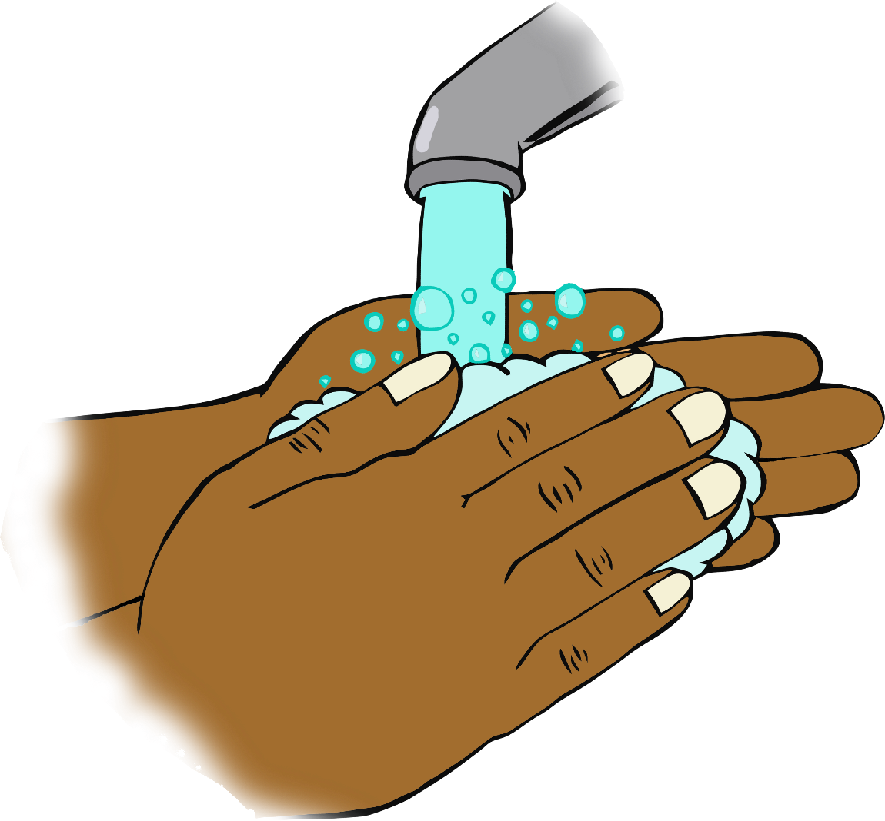

**I’m a super**

**hand washer!**

**Name Here**

© 2020 Little Owls Resources

24th July 2020

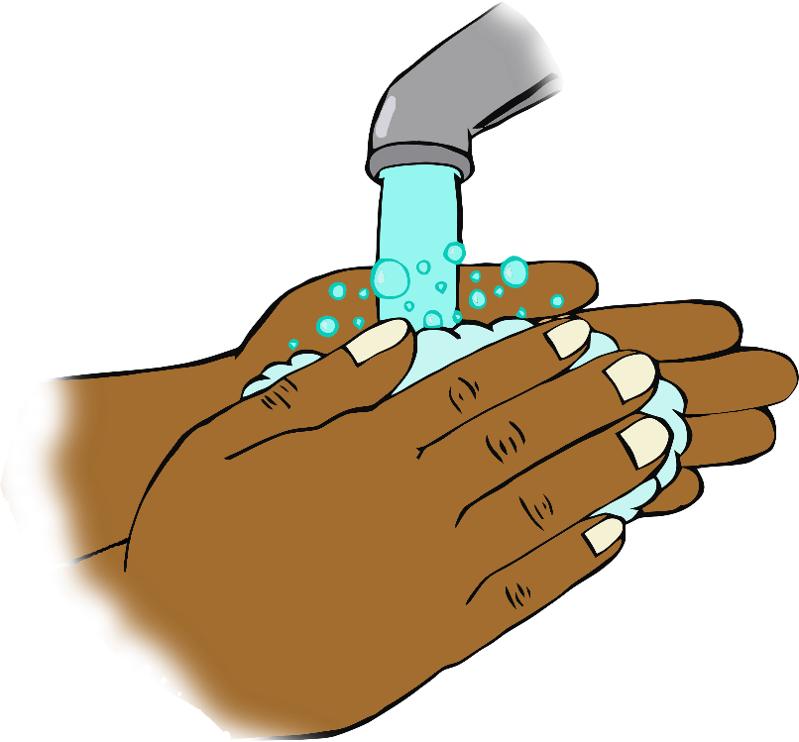

**I’m a super**

**hand washer!**

**Name Here**

© 2020 Little Owls Resources

24th July 2020

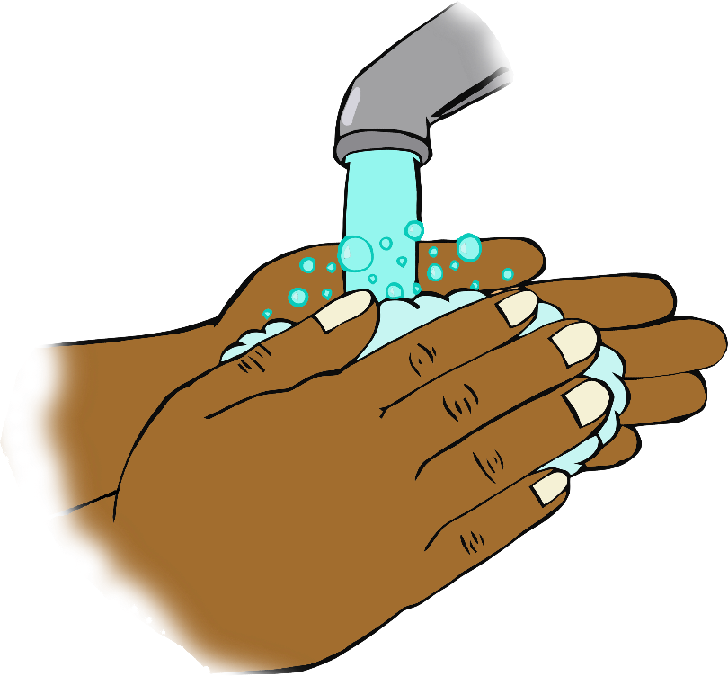

**I’m a super**

**hand washer!**

**Name Here**

© 2020 Little Owls Resources

24th July 2020