**Ice Cream Shop**

**Memory Game**

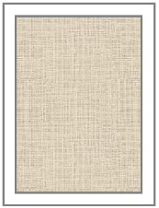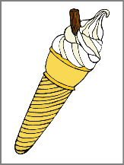 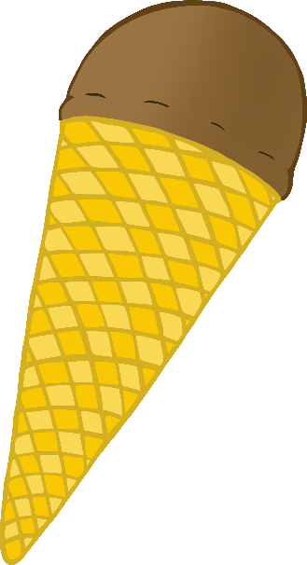

*\*Before laminating, fold along the central line to obscure the picture from the other side.*

© 2021 Little Owls Resources

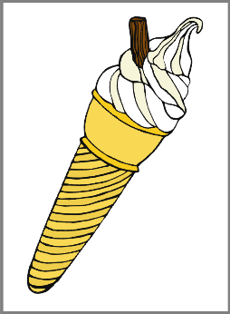

* Place all finished cards face down.
* Take turns to turn cards to find a match.

© 2021 Little Owls Resources

© 2021 Little Owls Resources

Owls Resources

© 2021 Little Owls Resources

© 2021 Little Owls Resources

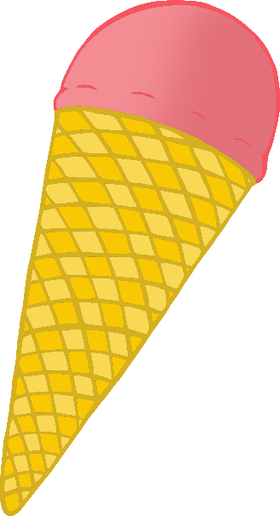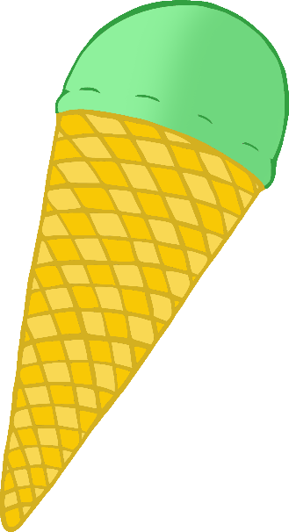



© 2021 Little Owls Resources

© 2021 Little Owls Resources

© 2021 Little Owls Resources

© 2021 Little Owls Resources

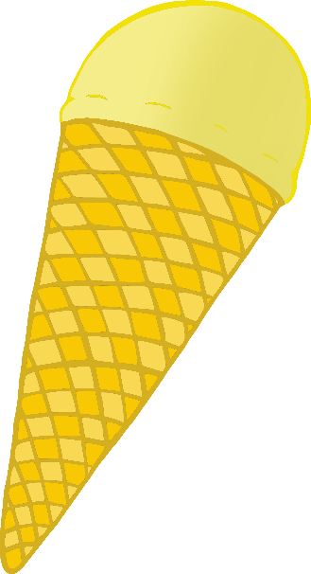

© 2021 Little Owls Resources

© 2021 Little Owls Resources

© 2021 Little Owls Resources

© 2021 Little Owls Resources

© 2021 Little Owls Resources

© 2021 Little Owls Resources

© 2021 Little Owls Resources

© 2021 Little Owls Resources

© 2021 Little Owls Resources

© 2021 Little Owls Resources

© 2021 Little Owls Resources

© 2021 Little Owls Resources

© 2021 Little Owls Resources

© 2019 Little Owls Resources

© 2021 Little Owls Resources

© 2021 Little Owls Resources

© 2021 Little Owls Resources