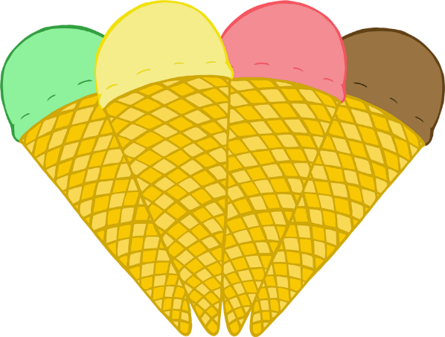

**Our**

© 2021 Little Owls Resources

**Favourite**

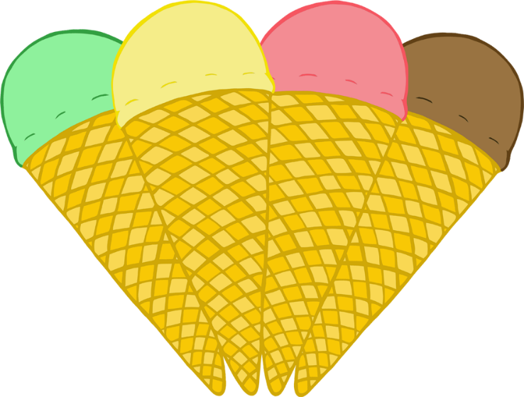

**Flavour**



**Our**

© 2021 Little Owls Resources

**Favorite**



**Flavor**

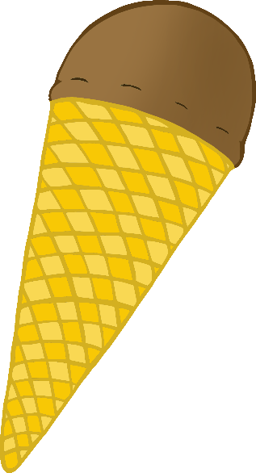

Ice-Cream Pictogram

Children to talk about their own preferences and choose a flavour.

Add to line on wall or floor to find the most popular.

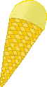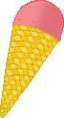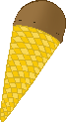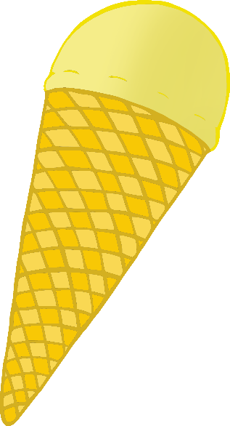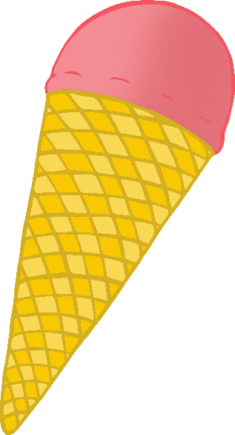

© 2021 Little Owls Resources

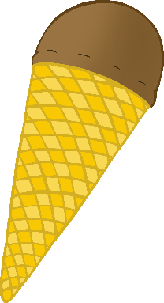



© 2021 Little Owls Resources

© 2021 Little Owls Resources

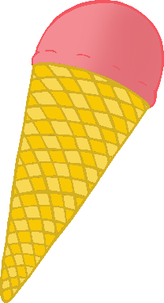



© 2021 Little Owls Resources

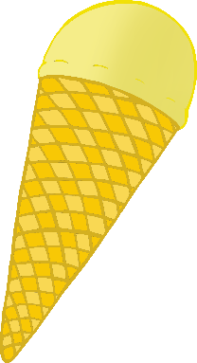

© 2021 Little Owls Resources