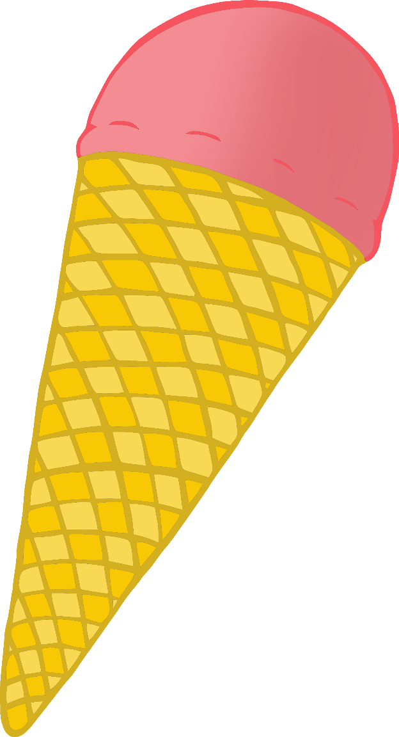

© 2022 Little Owls Resources

**Design your own**

**Ice Cream!**

© 2022 Little Owls Resources

© 2022 Little Owls Resources