I am feeling

happy

© 2023 Little Owls Resources

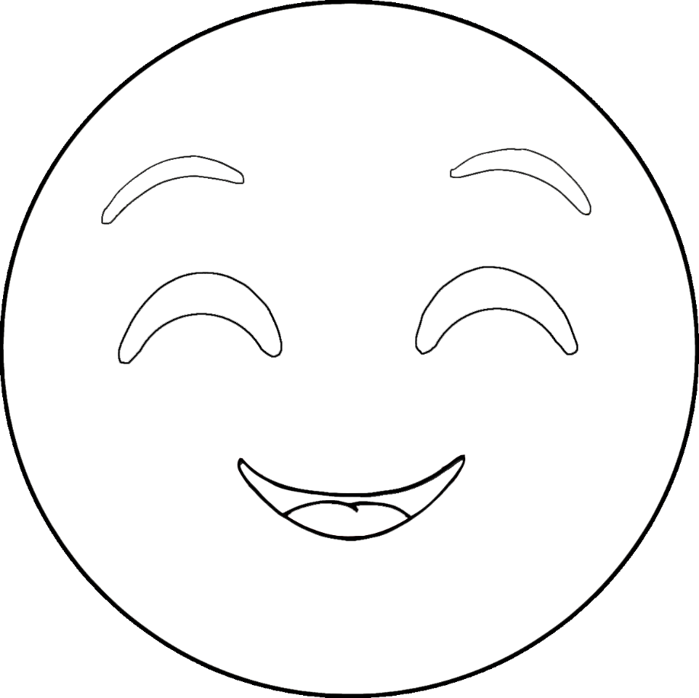

I am feeling

happy

© 2023 Little Owls Resources



I am feeling

confused

© 2023 Little Owls Resources

I am feeling

confused

© 2023 Little Owls Resources

I am feeling

excited

© 2023 Little Owls Resources

I am feeling

excited

© 2023 Little Owls Resources

I am feeling

sad

© 2023 Little Owls Resources

I am feeling

sad

© 2023 Little Owls Resources

I am feeling

scared

© 2023 Little Owls Resources

I am feeling

scared

© 2023 Little Owls Resources

I am feeling

worried

© 2023 Little Owls Resources

I am feeling

worried

© 2023 Little Owls Resources

I am feeling

love

© 2023 Little Owls Resources

I am feeling

love

© 2023 Little Owls Resources

I am feeling

sleepy

© 2023 Little Owls Resources

I am feeling

sleepy

© 2023 Little Owls Resources

I am feeling

fine

© 2023 Little Owls Resources

I am feeling

fine

© 2023 Little Owls Resources

I am feeling

angry

© 2023 Little Owls Resources

I am feeling

angry

© 2023 Little Owls Resources

I am feeling

bored

© 2023 Little Owls Resources

I am feeling

bored

© 2023 Little Owls Resources

I am feeling

frustrated

© 2023 Little Owls Resources

I am feeling

frustrated

© 2023 Little Owls Resources