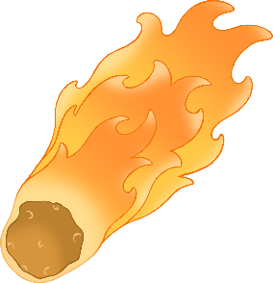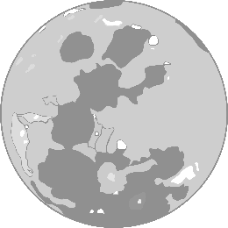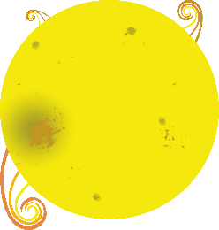

How many……?

Moons

Meteors

Shuttles

Suns

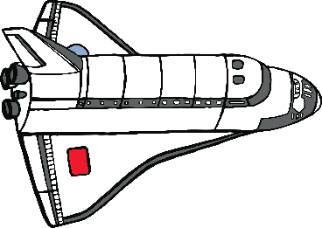

Asteroids

© 2021 Little Owls Resources

How many……?

Earths

Rockets

Astronauts

Telescopes

0

© 2021 Little Owls Resources